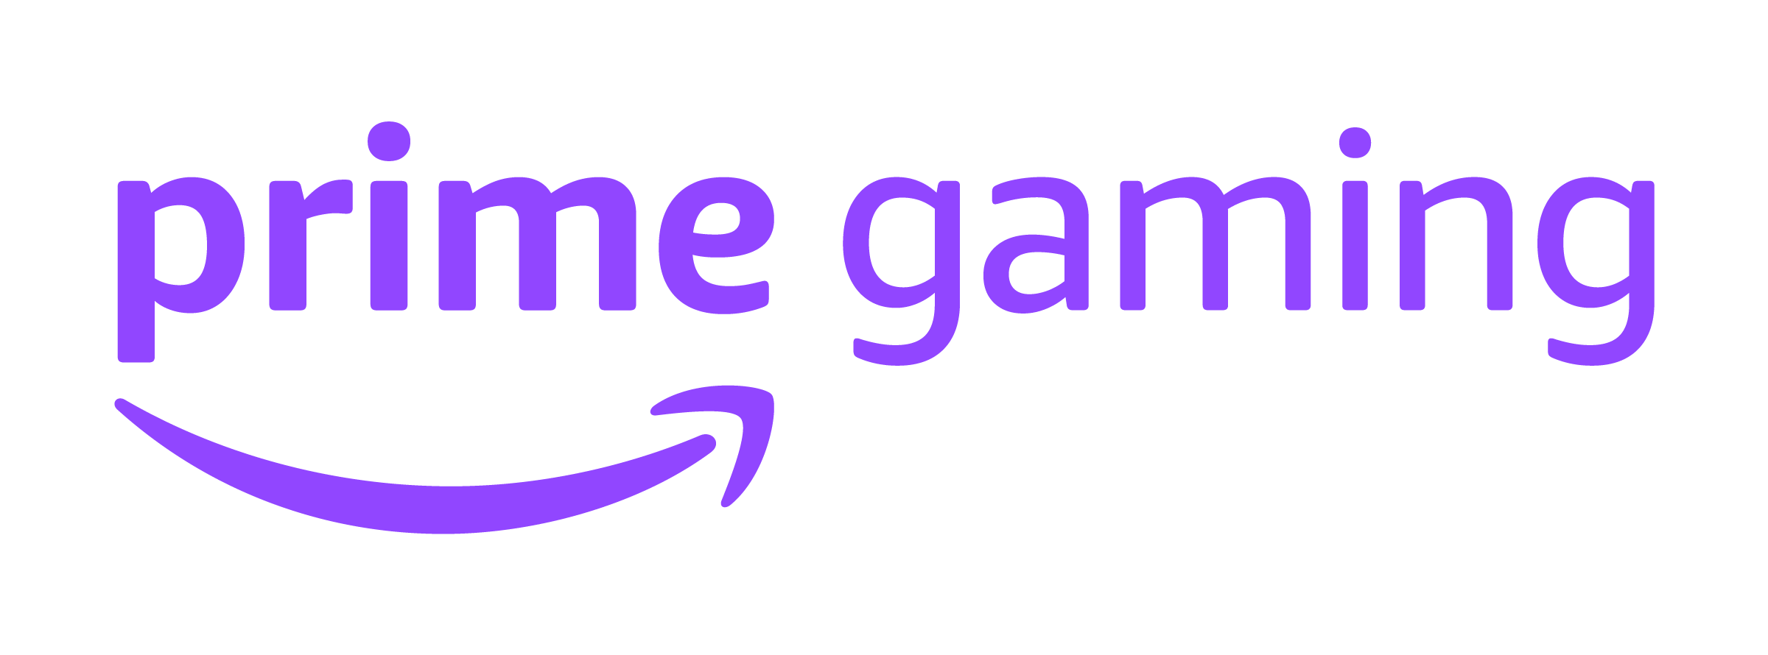 |  | Press Update  January 2021
January 2021 - Prime Gaming Monthly Update
Prime Gaming is ringing in 2021 with a fresh line up of content for Prime members, including exclusive content for over 30 popular games, plus a library of 35+ PC games available now —with even more coming soon!
January’s top Prime Gaming offers include:

- Prime Gaming content and GTA$ for Grand Theft Auto
- An exclusive winter-themed bundle for Fall Guys: Ultimate Knockout
- A whole new year’s worth of offers from League of Legends and Legends of Runeterra, with new content available to claim each month
- 35+ games, with titles like Alt-Frequencies, Void Bastards, Along the Edge and Bridge Constructor Playground joining the library in January
- Ad-free play for some of Voodoo’s most popular titles, including Aquapark.io and Cube Surfer

As a reminder, all of these offers can be claimed by visiting gaming.amazon.com. You can download assets here.

Read on for a look at all of the great content and games coming in January!

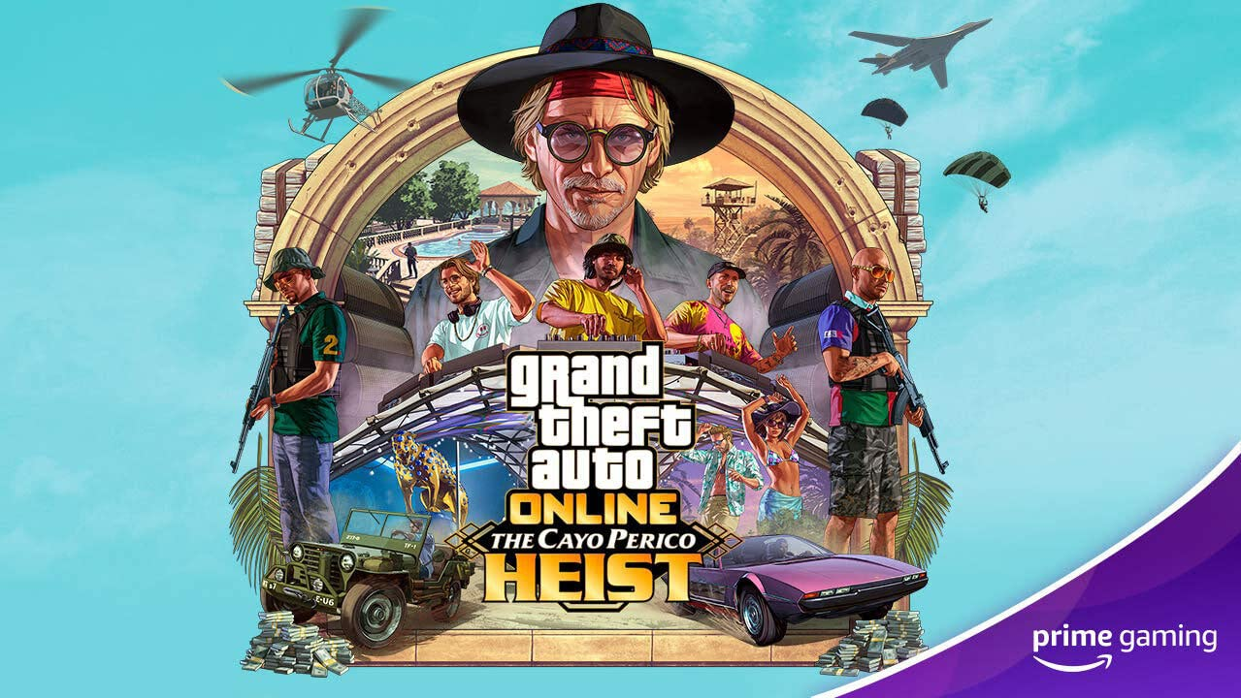
Let’s ride with bonus GTA Cash for Grand Theft Auto Online!
Available Now To celebrate Cayo Perico Heist, Grand Theft Auto Online’s biggest update ever, Prime Gaming is giving access to the Kosatka submarine’s Sonar Station, and up to GTA$1 Million every month.
If you haven’t already, connect your Amazon and Rockstar Games Social Club accounts to earn up to GTA$1,000,000 for each month you play GTA Online!
Visit gaming.amazon.com/loot/gtaonline to get started!
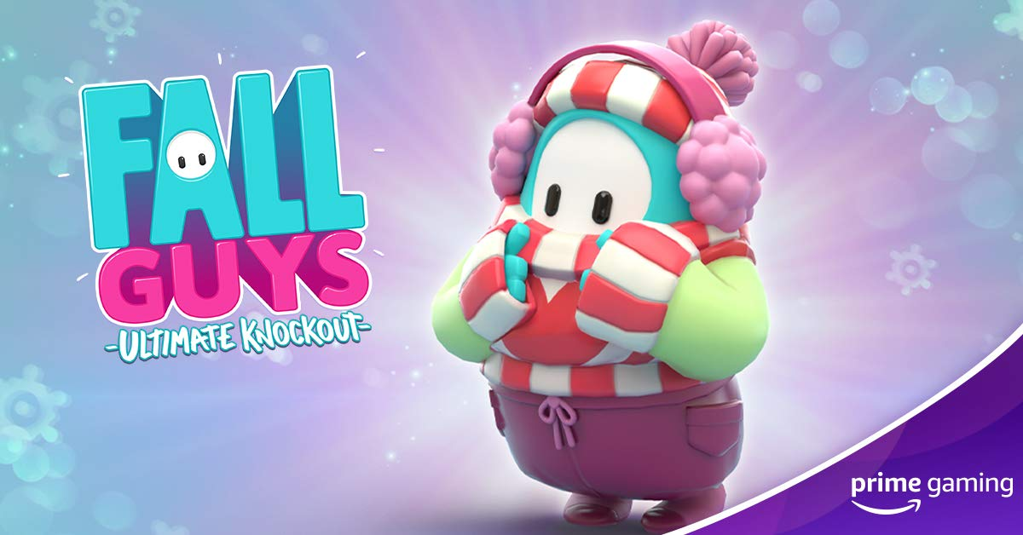
Jump Into Fall Guys Season 3 with an Exclusive Winter Warmer Bundle
Available Now Well the weather outside is frightful...but those beans are so delightful! While slipping and sliding through Fall Guys: Ultimate Knockout’s newly released Season 3, be sure to claim the Winter Warmer Bundle available exclusively with Prime Gaming. The bundle for this fan-favorite party game includes:
- Don the adorable Winter Warmer costume, the snowy peak of Blunderdome fashion! This costume is designed for pristine bumbling in icy conditions and looking fantastic while you’re at it.
- Three Crowns for use in the in-game store.
This is just the first of 6 Fall Guys content offers coming to Prime Gaming in the next few months--including more to come later in January!
Visit https://gaming.amazon.com/loot/fallguys for details.
Drop 1 of 6
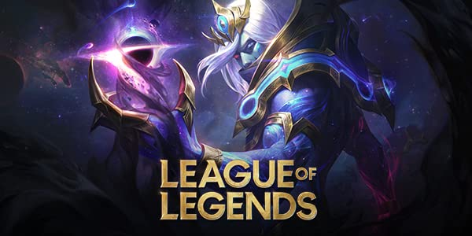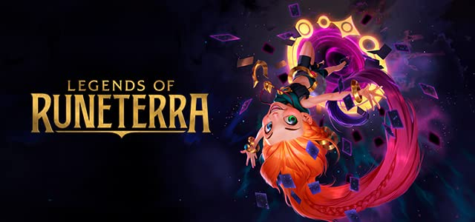
Ring in 2021 with a whole year of Riot content
Available Now We heard you like Riot content, so we’re bringing you even more in 2021, with a full year of awesome Prime Gaming offers for League of Legends and Legends of Runeterra! Every single month, Prime members can look forward to skin shards in League of Legends (36 total in 2021), plus an Epic Wildcard in Legends of Runeterra. Happy New Year!
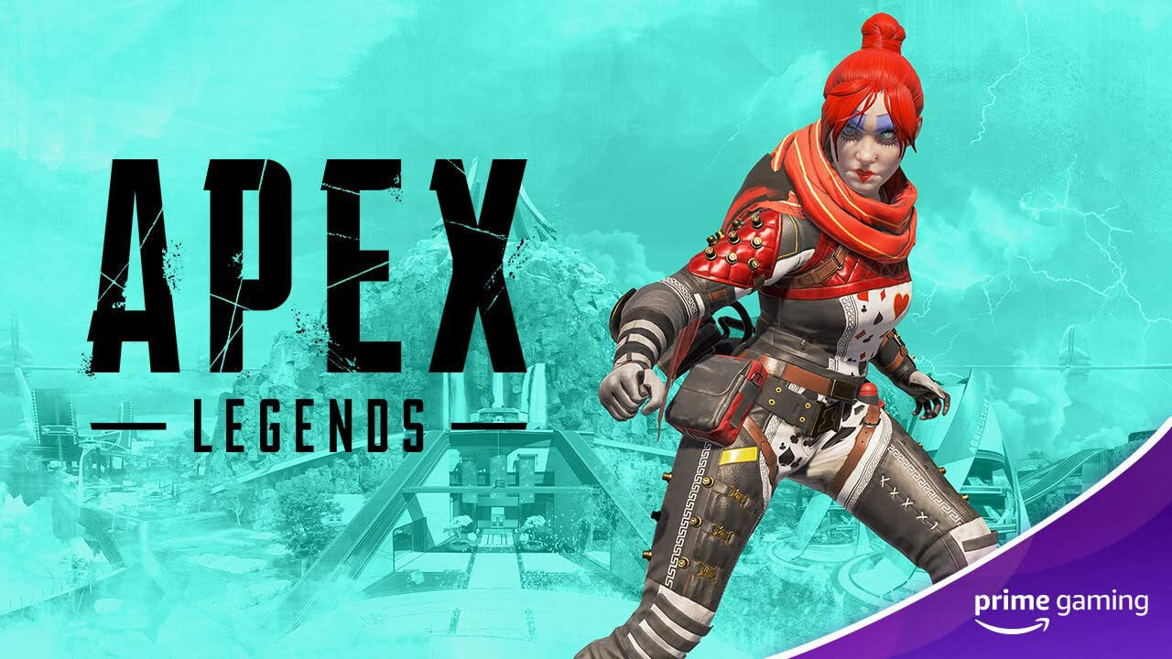
Warm up with an Apex Legends skin
Available Jan. 14 More Apex Legends content is on the way to Prime members in January! Claim the unique Queen of Hearts skin for Wraith, available only from Prime Gaming.
Drop 1 of 12
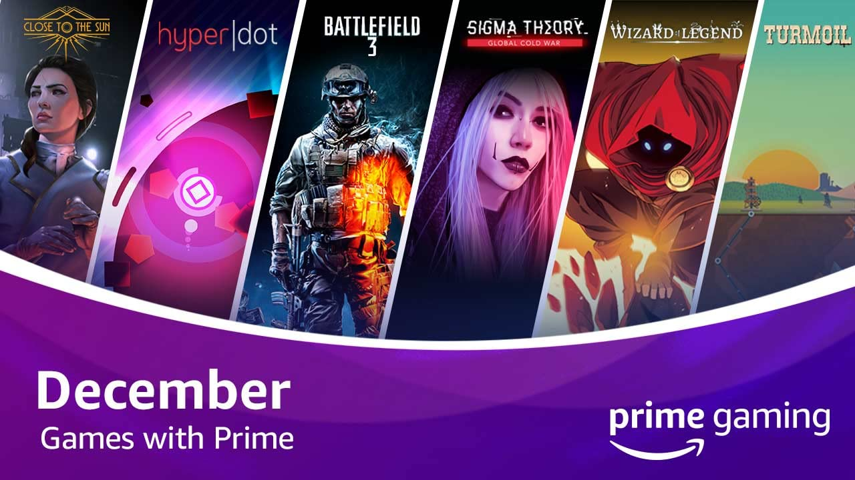
Jump start the new year with dozens of games!
Add 35+ games to your library in January, including Void Bastards and Along The Edge
Available Now Looking for a way to spend these cold and dark nights? Prime Gaming has you covered then! In January, over 35 games are yours for the taking, with more on the way. This month’s new games include a line-up ranging from immersive puzzle games to a fast-paced dungeon crawler.
Read on below for a look at the new games coming to Prime Gaming in January:
- When Ski Lifts Go Wrong - Ride into a hilarious construction puzzler packed with over 100 creative physics-based challenges, sports and bloody disasters.
- Void Bastards - A revolutionary new strategy-shooter that will test your wits and exercise your aim.
- Bridge Constructor Playground - Let your creative side run riot across 30 innovative levels building bridges over deep valleys, canals or rivers.
- Alt Frequencies - Record, rewind time and broadcast snippets of radio shows to expose radio hosts, conspiracy theorists and politicians.
- Along the Edge - a visual novel set in the European countryside, where your choices impact the main character's personality and appearance.
And, don’t forget to download select December games before they’re gone, including Yooka-Laylee and the Impossible Lair (leaving January 8)and Wizard of Legend (leaving January 15).
Prime members have unlimited access to a growing collection of PC games, with new titles added each week. We rotate our collection to keep titles fresh, so check back each week to claim new games and grab others before they’re gone. Prime Gaming offers hundreds of dollars’ worth of games and in-game content available at all times—and all games are yours to keep forever.
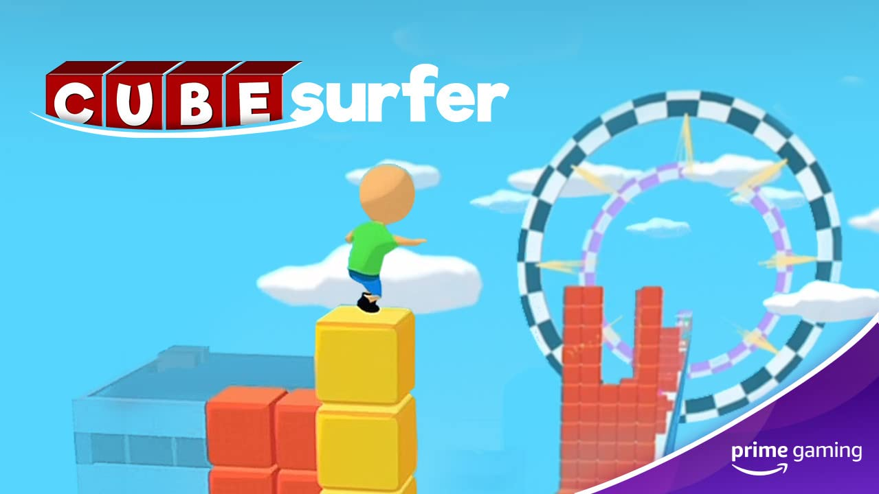
Enjoy Voodoo’s popular mobile games ad-free!
Prime Gaming and Voodoo, the publisher behind wildly popular mobile games like Hole.io and Aquapark.io, are teaming up to bring Prime members weeks of ad-free play that will delight the whole family. Right now, Prime members can enjoy ad-free play for a limited time on Cube Surfer and Aquapark.io, and there’s more on the way soon!
- Aquapark.io – Race to reach to the end of the water slide, while bumping other players in this colorful and sunny water slide game.
- Cube Surfer – Players are challenged in this 3D arcade game to stack cubes to make a tower run and surf on the road to reach the finish line by making a color line.
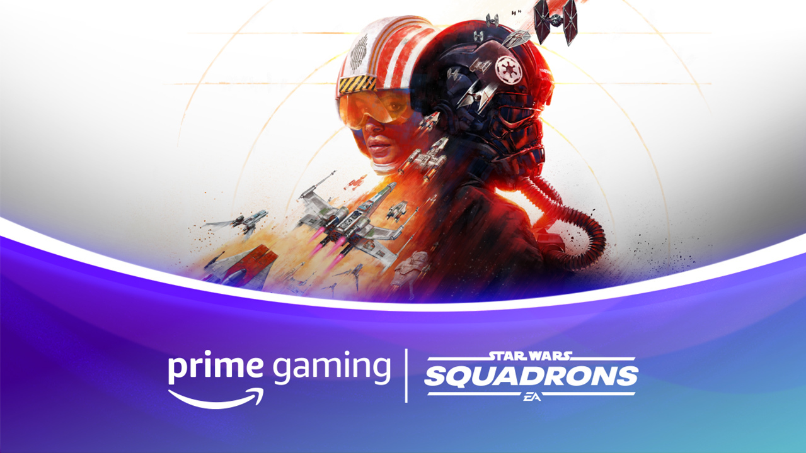 | 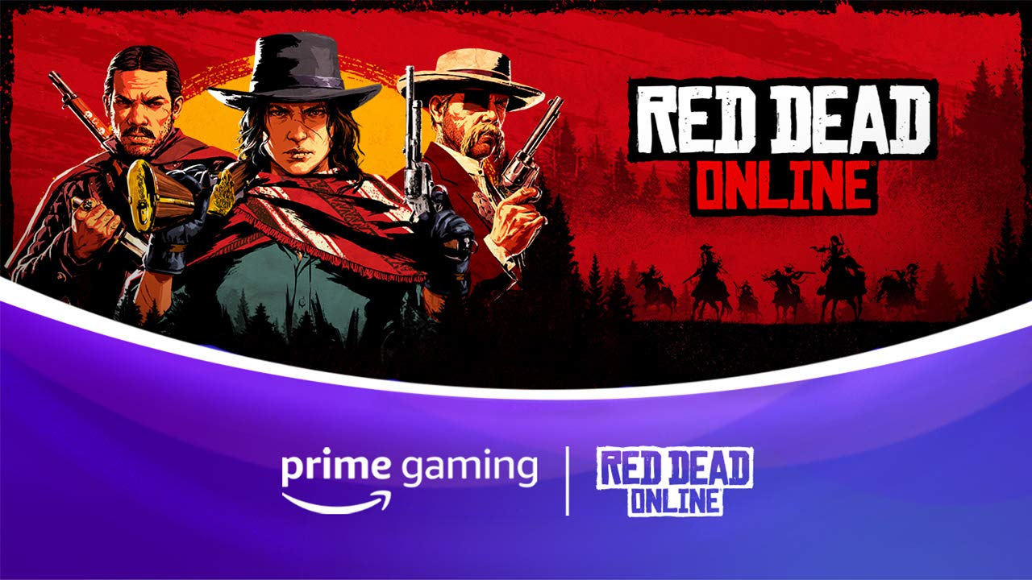 | 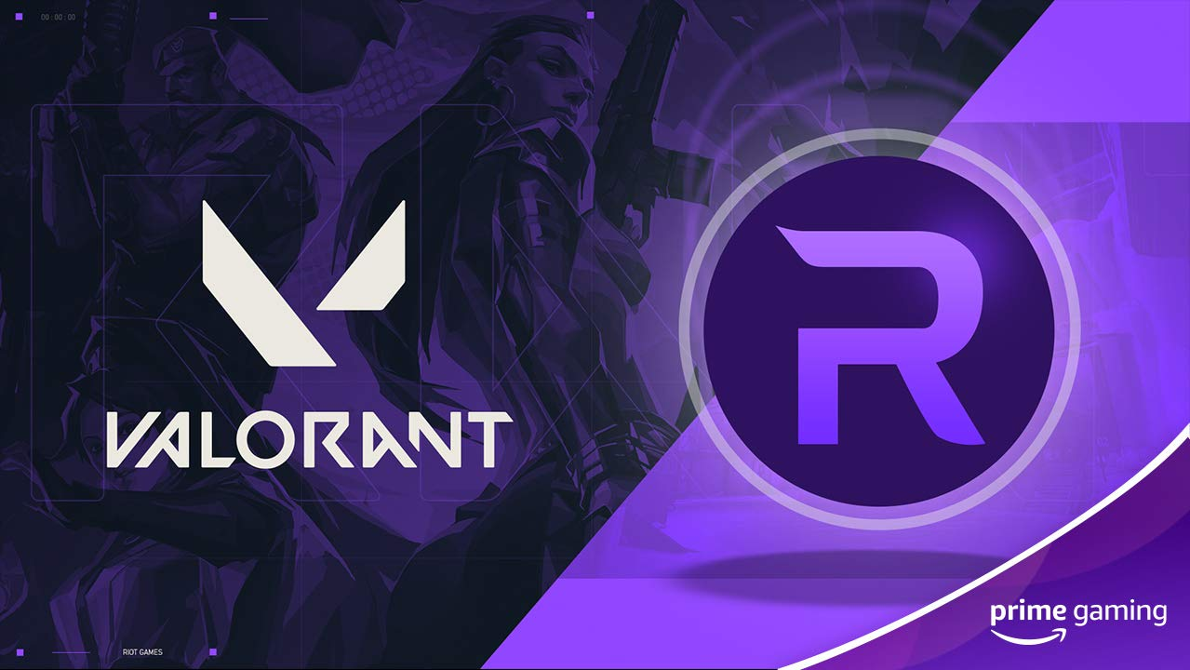
STAR WARS: SQUADRONS  Available Now  Ring in the new year by claiming two new pilot helmets for EA’s first-person space dogfighting experience!  Drop 2 of 4 | Red Dead Online  Available Now  This January, players can look forward to numerous Red Dead Online offers, including a Bounty Hunter License and a Purple Bounty Wagon Tint (requires 3 Role tokens and Rank 25+ Bounty Hunter). | VALORANT  Available January 19  Claim 10 Radianite Points in the popular 5v5 tac-shooter--and be sure to tune in to wwFest: VALORANT, an experimental music and art festival including musical performances from ARMNHMR, Moore Kismet, Ookay, Whipped Cream, and more, January 15 on Crown Channel.  Drop 1 of 3
 | 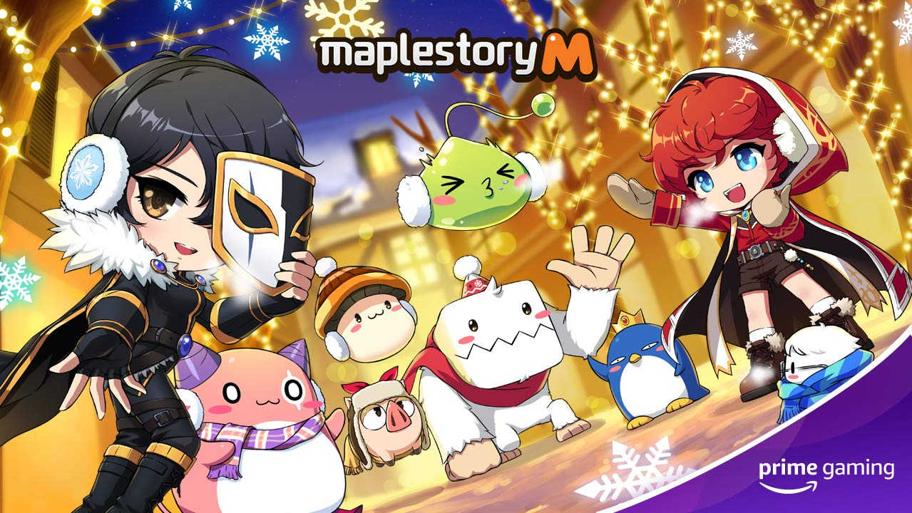 | 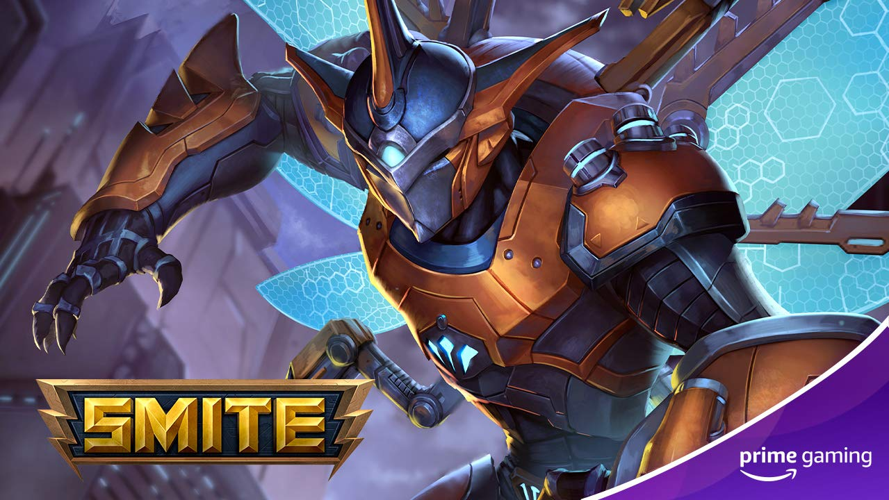
Madden NFL 21  Available Now  Start 2021 off right with a Zero Chill pack, including five 81+ Overall Zero Chill players, with the chance of getting one 89 OVR player.  Drop 3 of 11 | Maple Story M  Coming in January  Boost your stats with an Event Buff Pet, available for 14 days once you’ve equipped it. | SMITE  Available Now  New year, new Ah Muzen Cab--claim a new skin for the god of bees until January 25.  Drop 4 of 9
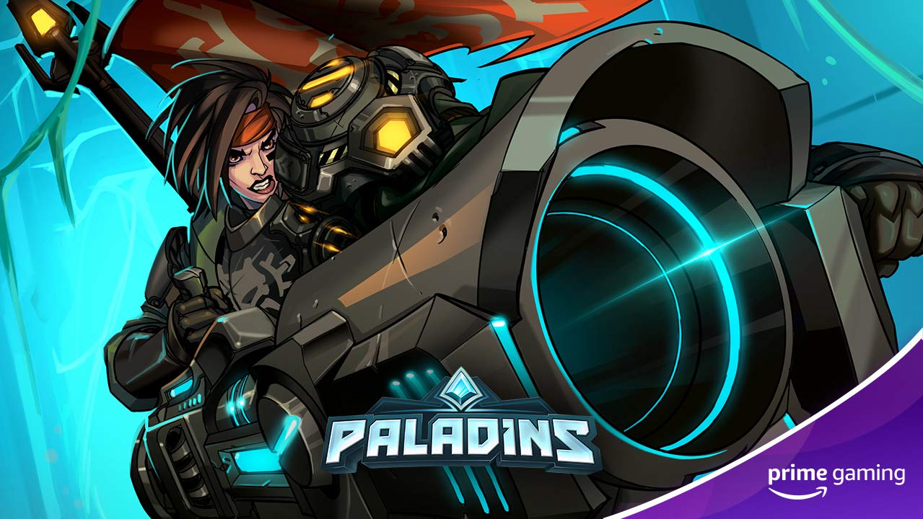 | 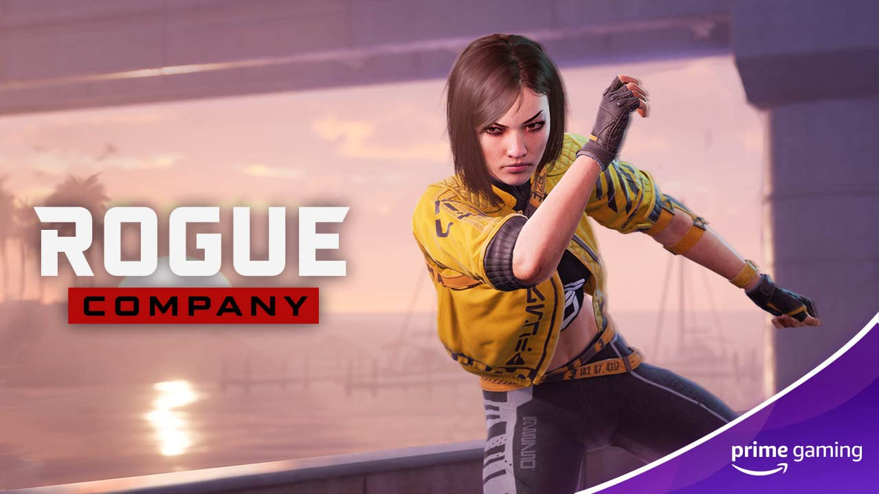 | 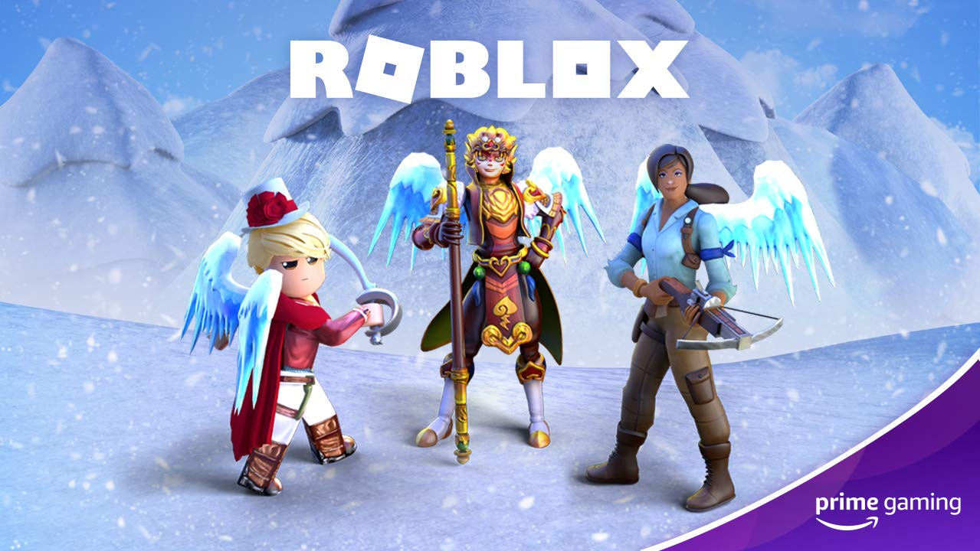
Paladins  Available Now  Buff up your new year with a Xeno-Buster Ash skin, available until January 28.  Drop 4 of 9 | Rogue Company  Available Now  Cozy up with the Kikuma Winter ‘20 Ronin outfit, available until January 28.  Drop 4 of 11 | Roblox  Available January 12  Add some winter sparkle to your January with Snow Wings, available until February 21.  Drop 6 of 8
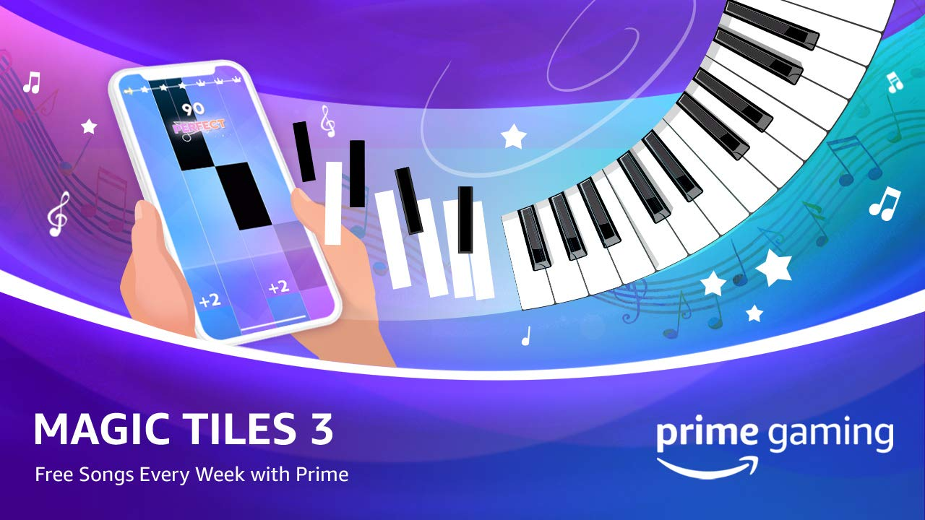
Magic Tiles 3
Available January 7, 14, 21
We have three 1-day VIP passes coming your way this month, including songs like Counting Stars (One Republic), Don’t Let Me Down (The Chainsmokers), and Close to the Sun (The Fat Rat). Each pass is available for just one week, so act quickly.
Drops 6-8 of 52
Calendar January 2021
Now Available Games with Prime - When Ski Lifts Go Wrong, Void Bastards, Bridge Constructor Playground, Alt Frequencies, Along the Edge
Now Available Grand Theft Auto content
Now Available Red Dead Online content
Now Available STAR WARS: SQUADRONS content, Drop 2
Now Available Madden NFL 21 content, Drop 3
Now Available Aquapark.io limited-time ad-free play
Now Available Cube Surfer limited-time ad-free play
Now Available League of Legends content, Drop 1
Now Available Legends of Runeterra content, Drop 1
Now Available SMITE content, Drop 4
Now Available Paladins content, Drop 4
Now Available Rogue Company content, Drop 4
January 7 Magic Tiles 3 content, Drop 6
January 8 Last chance to claim: Yooka-Laylee and the Impossible Lair
January 12 Roblox content, Drop 6
Coming in January Maple Story M content
January 14 Magic Tiles 3 content, Drop 7
January 15 League of Legends content, Drop 2
January 15 Last chance to claim: Turmoil, Sigma Theory: Global Cold War, HyperDot, Close to the Sun, Wizard of Legend
January 19 VALORANT content, Drop 1
January 21 Magic Tiles 3 content, Drop 8
January 25 League of Legends content, Drop 3
For the latest on content, offers and sweepstakes, follow Prime Gaming on Twitter, Facebook and Instagram.

About Prime Gaming
With Prime Gaming, Amazon Prime members enjoy tons of exclusive content for their favorite PC, console, and mobile games. Plus, they can claim a collection of PC games for every month that are theirs to keep forever, and a monthly Twitch channel subscription. Prime Gaming’s selection of in-game content and PC games is always growing and rotating to stay fresh, with new items and games added every month.

This is in addition to the many other benefits available with Prime, including the best of shopping and entertainment from Amazon, including fast, free delivery, along with exclusive savings, early access to deals, Prime Day, and so much more. Members enjoy unlimited streaming access to a vast collection of TV shows, movies, sports and more with Prime Video, ad-free listening of 2 million songs plus thousands of stations and playlists with Amazon Music, unlimited access to a rotating selection of more than 1,000 books and magazines with Prime Reading, and unlimited photo storage with Amazon Photos.

