KONGSBERG supplies integrated propulsion, electro and automation package for eco-friendly bulk carrier
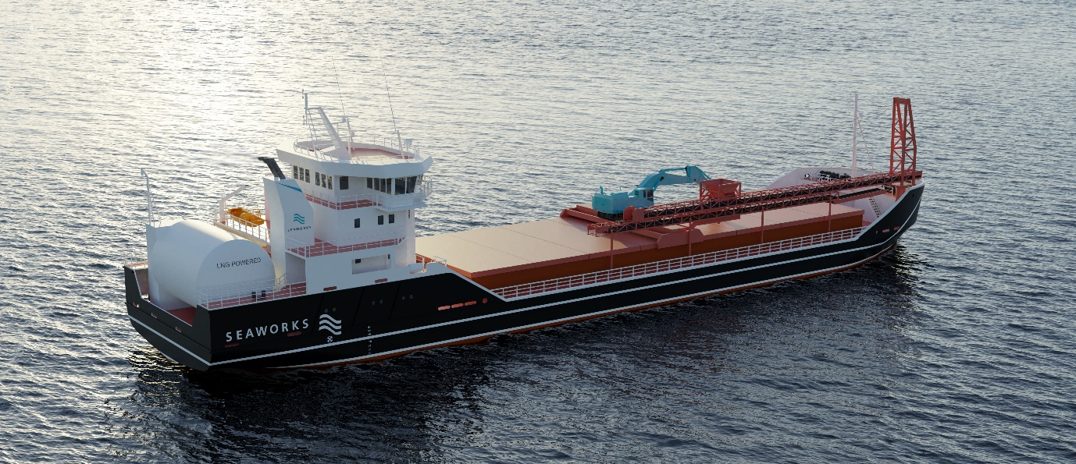
Seaworks’ new gas-powered vessel will use an extensive integrated systems package from Kongsberg Maritime
Kongsberg, Norway, 6th July 2021 – Kongsberg Maritime (KM) has been commissioned to deliver a comprehensive, integrated equipment and systems package for an ambitious and environmentally-responsible new bulk carrier project.
The gas-powered ship – which can be fuelled using either zero CO₂ emission LBG (Liquefied Biogas) or conventional LNG – is being built for the Norwegian short sea shipping company Seaworks, utilising a design which originated with Norway’s leading vessel architects, Polarkonsult. Having been impressed with KONGSBERG’s products, services and support on previous commercial marine projects, Polarkonsult approached KM with a view to supplying a propulsion system and LNG engine for the new bulk carrier. During the consultation, KM proposed an integrated solution which would enhance operational efficiency and prove far more cost-effective than separate systems, and this is the approach which has been agreed upon.
KM’s scope of delivery for the newbuild bulk carrier is extensive. The mechanical aspects of the integrated solution encompass steering and reduction gear, bow and stern thrusters, the rudder, a controllable pitch propeller system and a Bergen gas main engine. On the electrical and digital side, the delivery includes energy and power management systems, an energy storage unit, an electro package and a K-Chief marine automation system for monitoring and control of all key vessel functions.
“Our experience with KM as a system supplier and with their cutting-edge expertise and technical advice on the individual elements – engine, gear, propeller system, electrical, battery pack, etc. – has been of invaluable help in the design of the vessel,” says Arne Markussen, Sales Manager and Senior Project Engineer, Polarkonsult. “The personal collaboration with KM's representatives at the various levels and subject areas has also been very good. The fact that both the shipping company, consultant and supplier have spoken the same language has also simplified the process, although of course we handle partners from other nations on a daily basis.”
The bulk carrier is now being constructed in Wuhu, China after a careful tendering process saw 15 shipyards throughout Europe and China bidding for the contract. Pandemic restrictions unavoidably slowed down the contract negotiations, resulting in a few months’ delay to the original schedule. Nevertheless, all parties concerned have shown unflagging determination to see the project through, and construction is now back on track.
“Owing to the exceptional global circumstances, getting the build properly under way has been a long road, which began in March 2020, but it’s a project well worth persevering with,” says Bård Bjørløw, EVP Global Sales and Marketing, Kongsberg Maritime. “We’re moving towards halving the emissions you’d normally associate with vessels of this size and specification, so this bulk carrier represents something of a showcase for fuel-efficient, future-focused and environmentally-friendly maritime freight transport solutions. It also exemplifies our ‘One KONGSBERG’ approach, in which numerous aspects of our business come together to share and integrate technological insights, experience and expertise.”
Ends

For further information, please contact:
Gunvor Hatling Midtbø, VP Communication
Kongsberg Maritime
Tel: +47 9921 4209
gunvor.hatling.midtbo@km.kongsberg.com
David Pugh
Saltwater Stone
Tel: +44 (0)1202 669244
d.pugh@saltwater-stone.com

About Kongsberg Maritime
Kongsberg Maritime is a global marine technology company providing innovative and reliable ‘Full Picture’ technology solutions for all marine industry sectors including merchant, offshore, cruise, subsea and naval. Headquartered in Kongsberg, Norway, Kongsberg Maritime has manufacturing, sales and service facilities in 34 countries.
Kongsberg Maritime solutions cover all aspects of marine automation, safety, manoeuvring, navigation, and dynamic positioning as well as energy management, deck handling and propulsion systems, and ship design services. Subsea solutions include single and multibeam echo sounders, sonars, AUV and USV, underwater navigation and communication systems.
Training courses at locations globally, LNG solutions, information management, position reference systems and technology for seismic and drilling operations are also part of the company’s diverse technology portfolio. Additionally, Kongsberg Maritime provides services within EIT (Electro, Instrument & Telecom) engineering and system integration, on an EPC (Engineering, Procurement & Construction) basis.
Kongsberg Maritime is part of Kongsberg Gruppen (KONGSBERG), an international, knowledge-based group that celebrated 200 years in business during 2014. KONGSBERG supplies high-technology systems and solutions to customers in the oil and gas industry, the merchant marine, and the defence and aerospace industries.
Web: Kongsberg Gruppen | Kongsberg Maritime
Social media: LinkedIn | Twitter | Facebook

