Press Update
March 2021
March 2021 - Prime Gaming Monthly Update

Welcome to the March Prime Gaming press update! Just in time for Spring, Prime Gaming is blooming with a great collection of games and content for top games, including:

- Exclusive content for Fall Guys: Ultimate Knockout
- The March Games with Prime lineup, featuring Bomber Crew Deluxe and SkyDrift
- Plus, the last chance to claim 20+ SNK arcade classics

All of these offers can be claimed by visiting: gaming.amazon.com. As always, Prime Gaming offers are available for a limited time, so be sure to act fast before these offers disappear!

You can find information on this month’s lineup, as well as the latest and greatest Prime Gaming news on the Prime Gaming blog, and download assets here.

Read on below for a look at all of the great content and games coming in March!

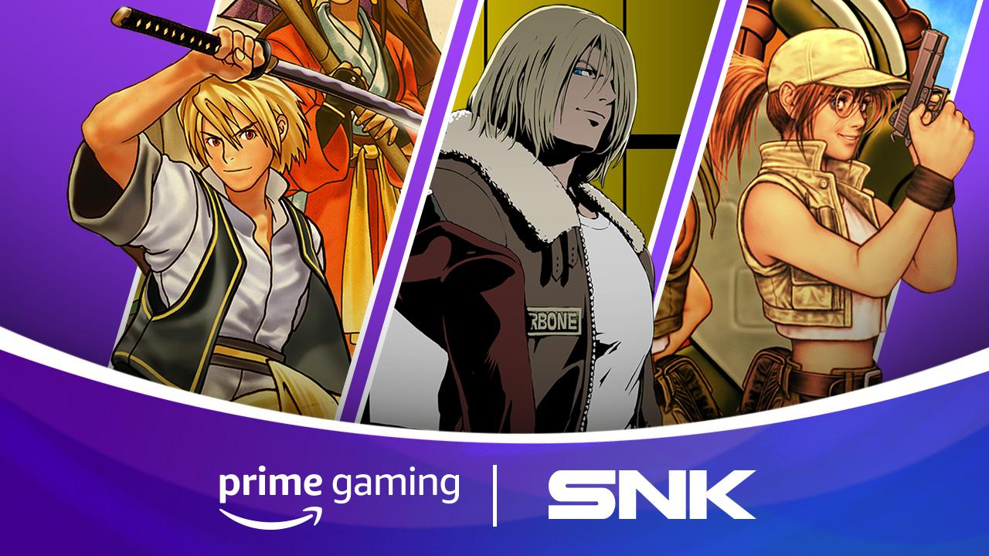
Last Chance: Claim 20+ Classic SNK Arcade Games Until March 31!
Available Now Don’t forget to claim this collection of arcade classics from legendary video game developer SNK. March is the last chance for Prime members to claim over 20 free iconic titles including Shock Troopers, Metal Slug 2, The King of Fighters 2000 and more--all theirs to keep forever.
The expansive SNK library offers something for all gamers, from longtime arcade fans to newcomers brand new to these classics.
Be sure to download these classics before they’re gone on March 31 and view a new Last-Chance sizzle video here.
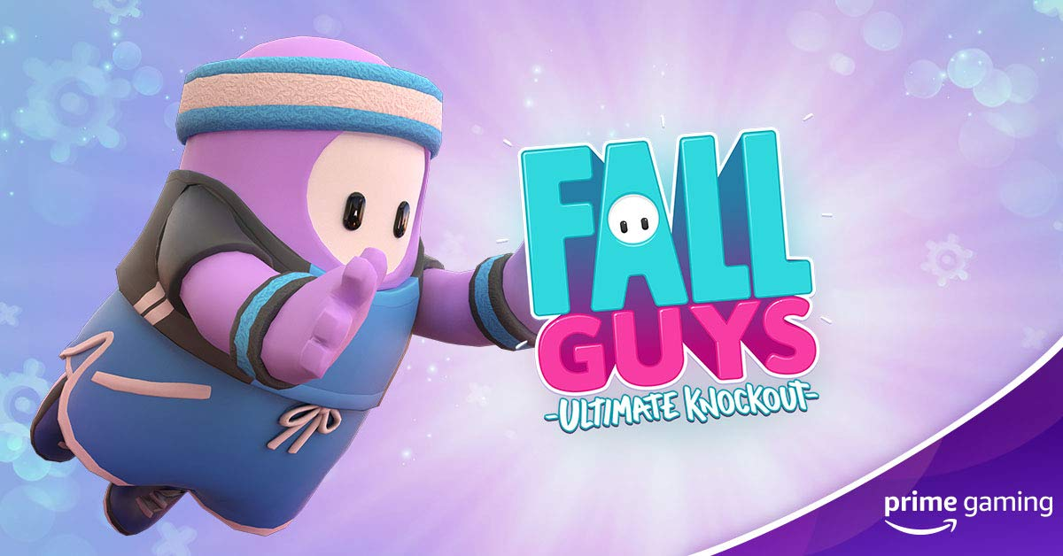
Grab the Fall Guys MVP Bundle with Prime Gaming!
Available Now Just in time for the season 3.5 update, Prime Gaming is offering an exclusive MVP Bundle for the hit party game Fall Guys: Ultimate Knockout! This new bundle includes the super-sporty MVP Costume and three whole Crowns, so players will always have a slice of that delicious Fall Guys glory. This costume has been specially crafted for optimal stumbling, with stylish sweatbands and athletic shorts!
Drop 3 of 6
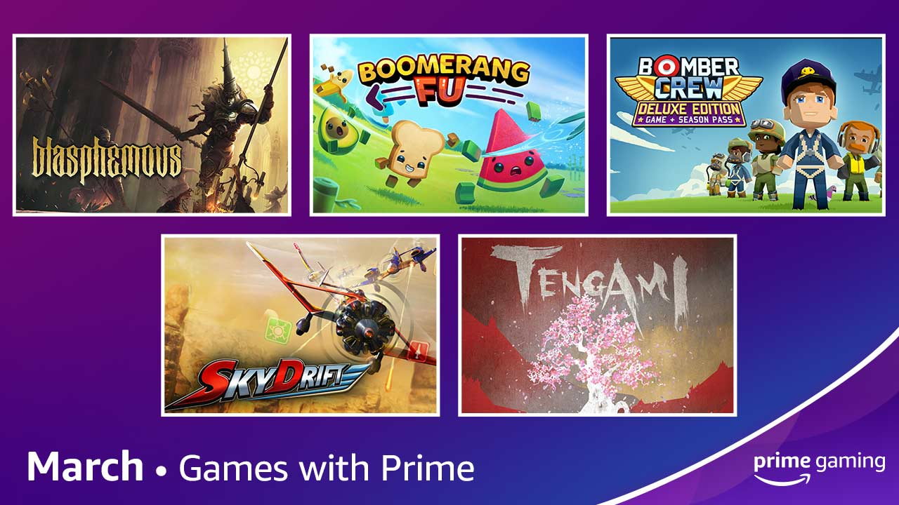
Spring into March with More Games!
Add games including Blasphemous and Boomerang Fu to your library
Available March 1 Prime Gaming is adding FIVE games to our library beginning Monday, March 1! The lineup includes something for everyone, ranging from brutal action-platformer Blasphemous to the frantic physics party game SkyDrift.
- Bomber Crew Deluxe - In this strategic simulation game, picking the right crew and keeping your bomber in tip top shape is the difference between completing your mission or losing it all.
- Blasphemous - Explore, upgrade your abilities, and perform savage executions on the hordes of enemies that stand between you and your quest to break eternal damnation.
- SkyDrift - Get closer than ever before to the world of adrenaline pumping sky-racing where flyboys can test and master their flying and combat skills against the deadliest opponents!
- Boomerang Fu - Join a crew of your favorite foods as you grill, chill and spill your enemies.
- Tengami - Fold and slide the beautifully crafted paper world to solve puzzles and discover secrets.
This lineup of games joins the impressive library of games already available to Prime Gaming members! We rotate our collection to keep titles fresh, so check back each week to claim new games and grab others before they’re gone. As always, all games are yours to keep forever.
 | 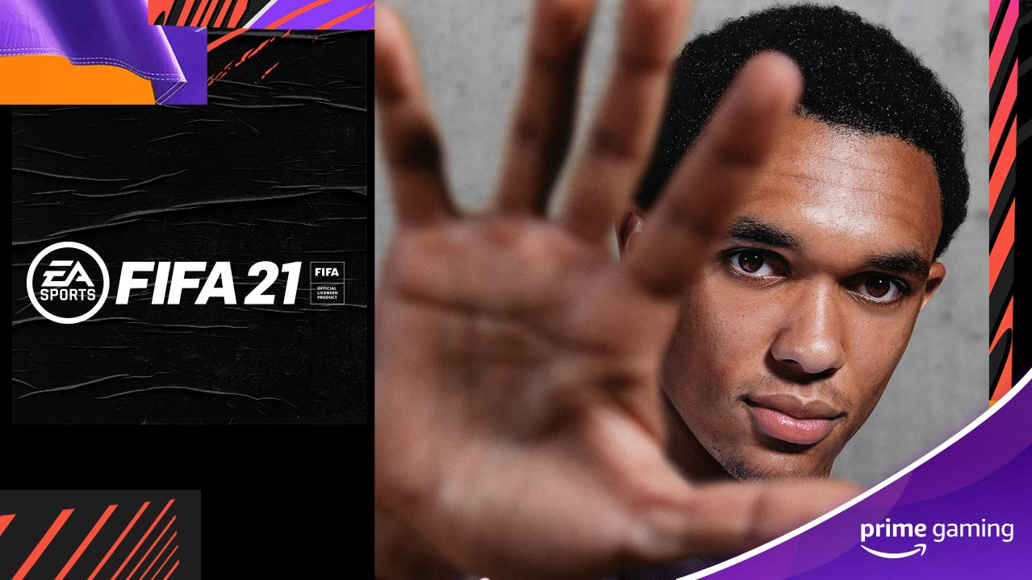 | 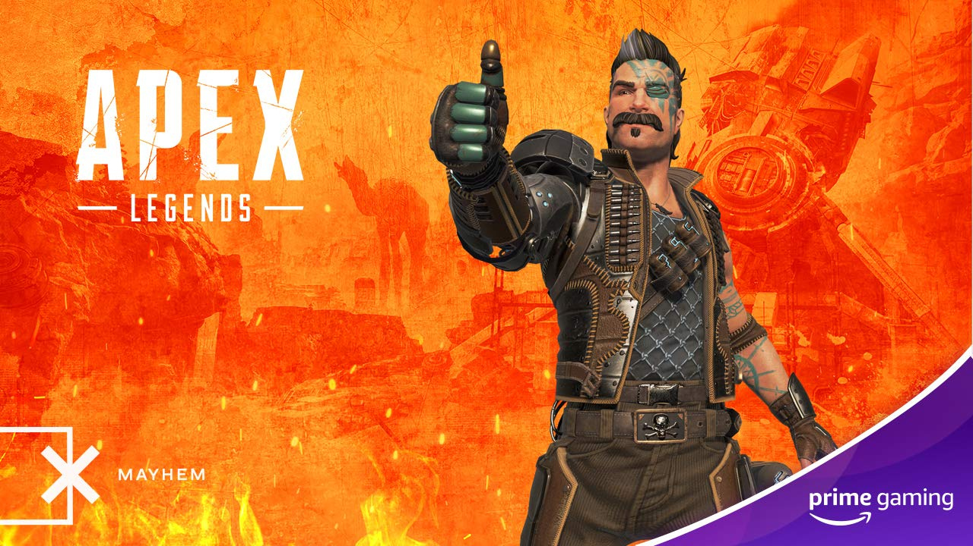
GTA Online  Let’s ride! Grab the Kosatka Submarine Sonar Station and GTA$1,000, 000 for the wildly popular GTA Online. | FIFA 21  Available March 22  This month, players can build their dream squad Pack #3, which includes 1x 81+ OVR Player Pick item and 4x Rare Gold Player items.  Drop 3 of 9 | Apex Legends  Drop 3 (Available Now)  Drop 4 (March 10)  Spring into action with an exclusive Fuse skin available in the free-to-play Battle Royale game until March 15. In addition, beginning on March 10, players can look forward to a brand-new Octane skin!
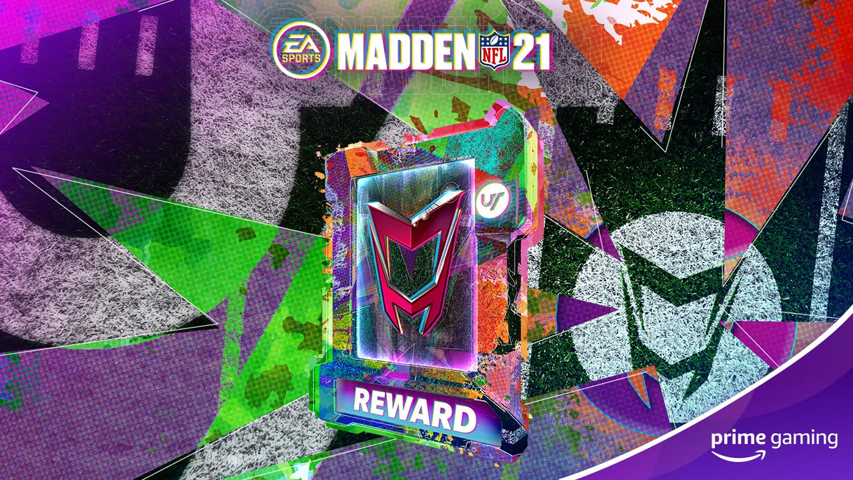 | 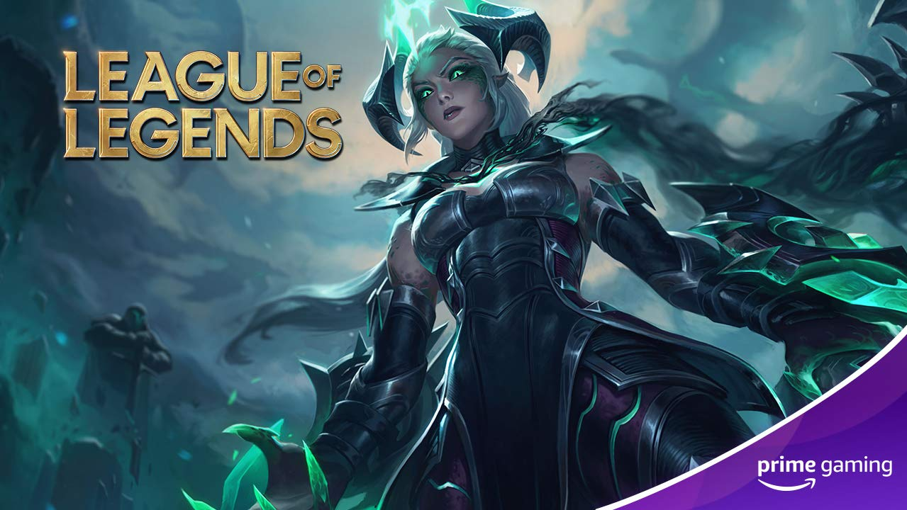 | 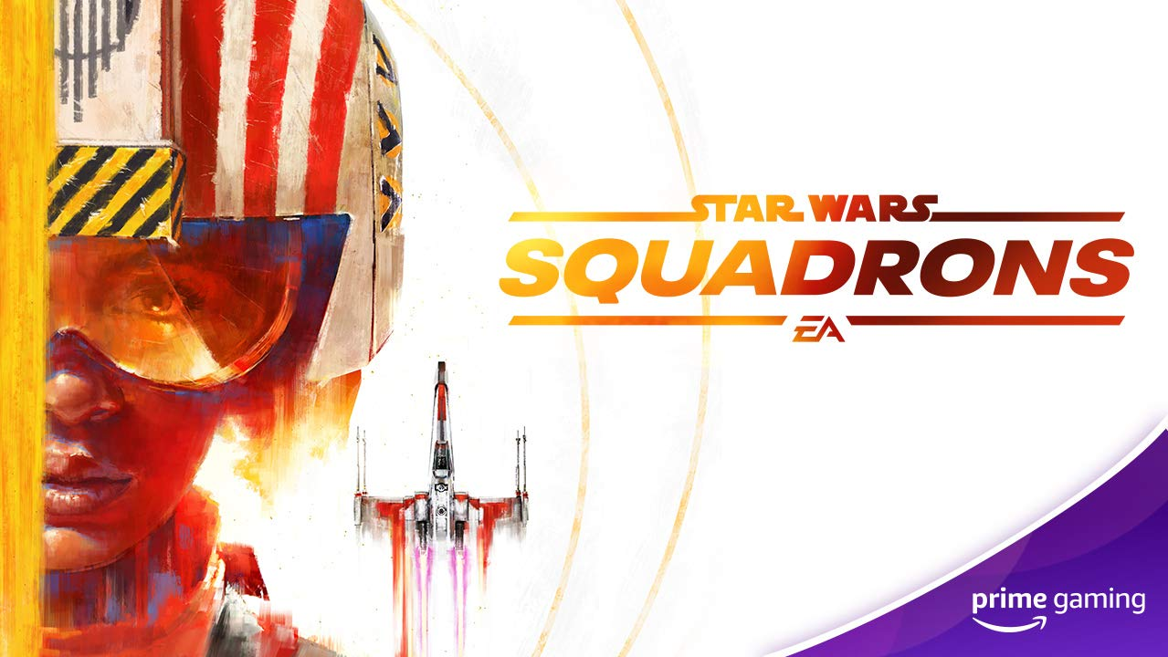
Madden NFL 21  Available March 8  Optimize your team with the Prime Gaming Pack, which features MUT Heroes this month!  Drop 7 of 11 | League of Legends  Drop 7 (March 8)  Drop 8 (March 18)  Drop 9 (March 29)  Be sure to unlock 3 mystery Skin Shards in League of Legends!  Drop 7 of 36 | STAR WARS: Squadrons  Available March 2  Soar the skies in style with two Pilot Helmets:  - FEARLESS SKIES – A pattern evoking the hyperwinds of Utapau, and a reminder that New Republic pilots weather any challenge.  - IMPERATOR’ S VISAGE – In the strategic game of Shah-tezh, the Imperator represents the supreme might of the Empire.  Drop 4 of 4
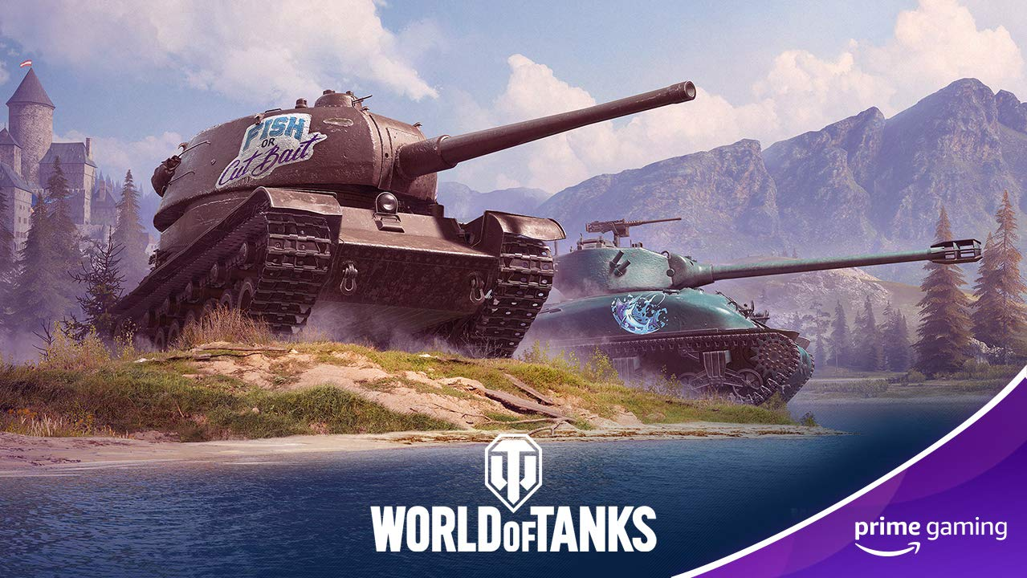 | 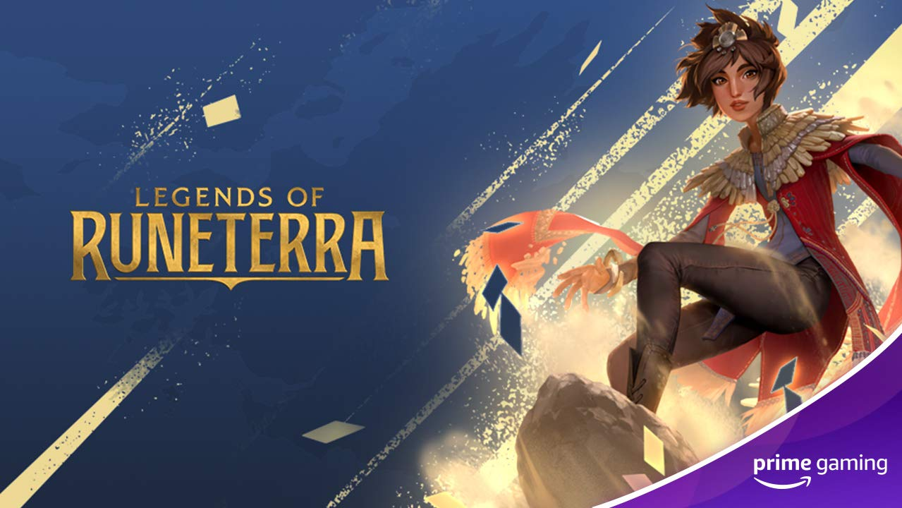 | 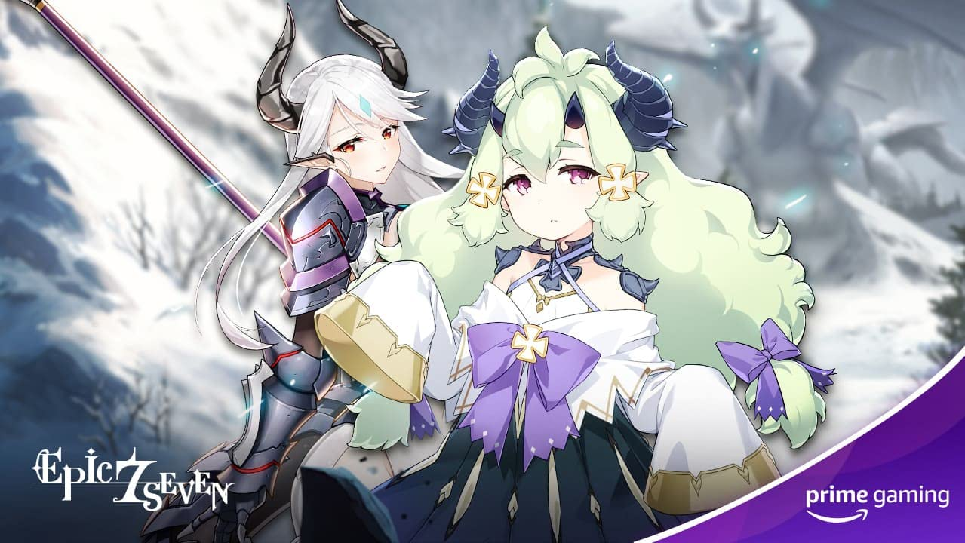
World of Tanks  Drop 2: Available Now  Drop 3: March 18  Grab 1 day of Premium Account, an exclusive The Big Catch decal, and the exclusive Fish or Cut Bait inscription before this offer ends on March 18. And check back on March 18 for more World of Tanks content!  Drops 2-3 of 17 | Legends of Runeterra  Available March 9  Pick up an Epic Wildcard in Riot Games’ Legends of Runeterra!  Drop 3 of 12 | Epic Seven  Drop 2: Now Available  Drop 3: March 10  Drop 4: March 24  Be sure to claim the following items:  Drop 2: 3x Greater Artifact Charms, 500,000 Gold through March 10  Drop 3: 9 x 3 - Star Penguin (3 perelement; Fire, Ice and Earth), 500,000 Gold through March 24  Drop 4: 20 x Leif through April 7  Drops 2-4 of 18
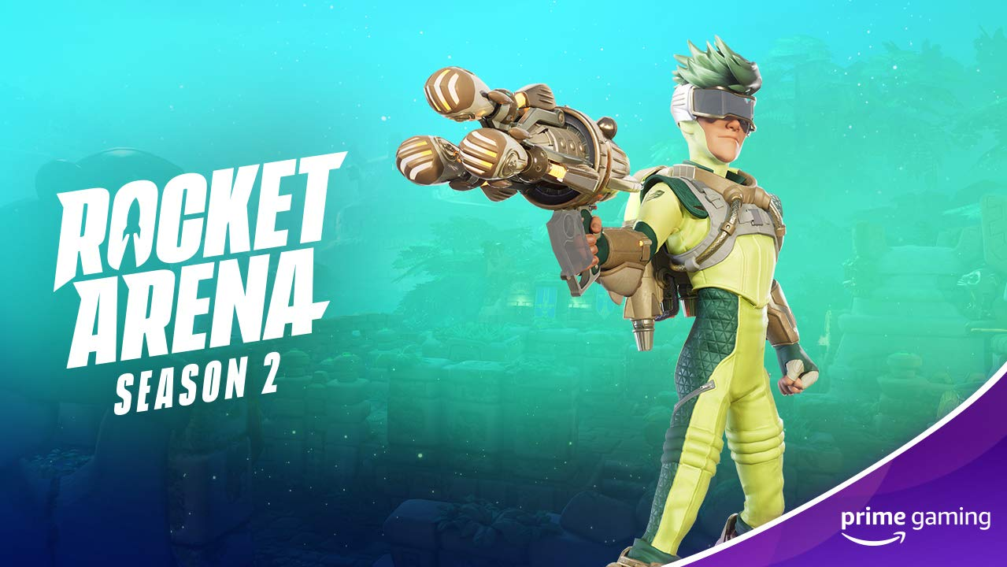 |  | 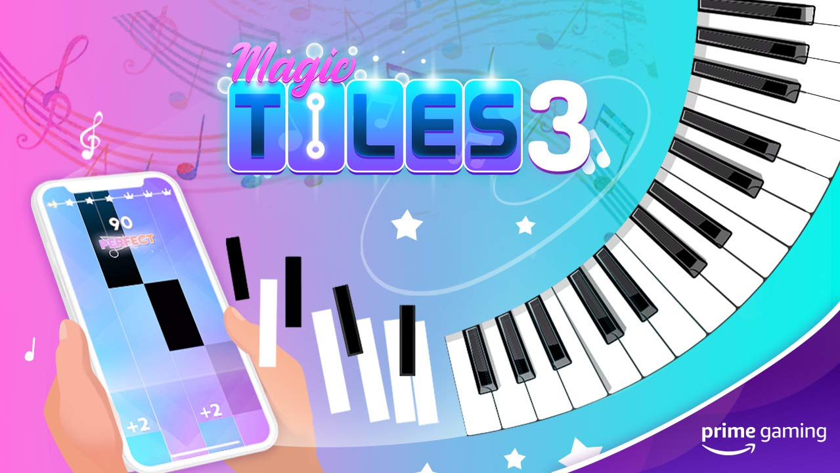
Rocket Arena  Available March 12  Battle in style: Get the all-new outfit for Jayto.  Drop 6 of 8 | MapleStoryM  Available March 10  This month, players can look forward to grabbing a 10,000,000 Red Meso Exchange Ticket x5.  Drop 3 of 12 | Magic Tiles  Available March 4  Unlock One-Day VIP pass and 5 additional songs, every week!
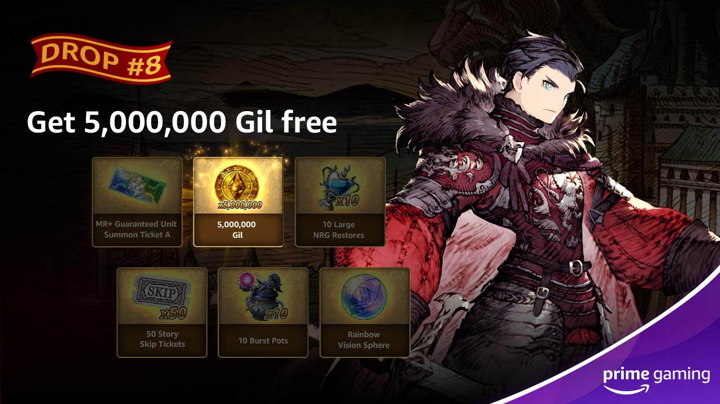 | 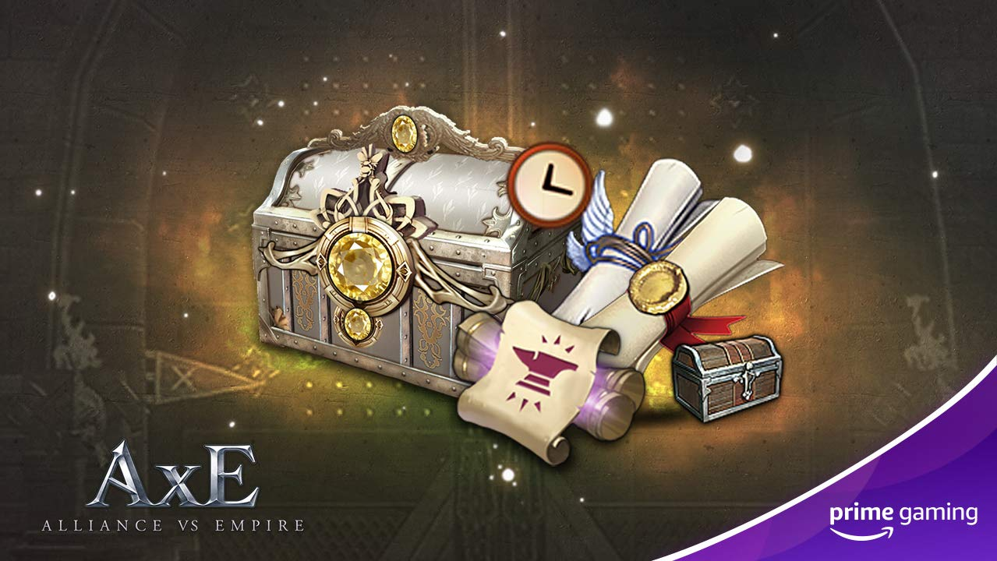 | 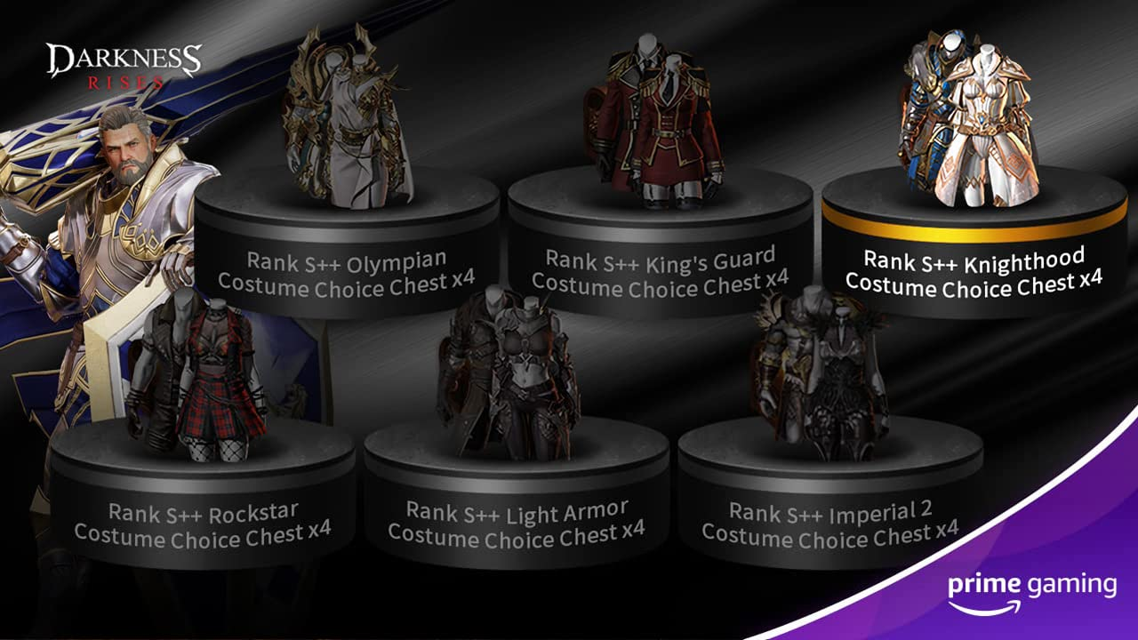
WAR OF THE VISIONS FINAL FANTASY BRAVE EXVIUS  Drop 8: March 3  Drop 9: March 17  March brings lots of WAR OF THE VISION FINAL FANTASY BRAVE EXVIUS content! On March 3, Prime members can claim a Gil x5,000,000 and on March 17, players can snag a NRG Restore (L) x10! | Alliance vs. Empire  Coming this March  Prime Members can look forward to claiming a White Diamond x500, Emerald x50, Enhancement Guard Ticket x50, King's Blessing x2 and Benuv's Blessing x2 in the most immersive and large-scale MMORPG on a phone this month.  Drop 1 of 12 | Darkness Rises  Available March 11  Beginning March 11, players can claim a Rank S++ Costume Choice Box x4.  Drop 4 of 12
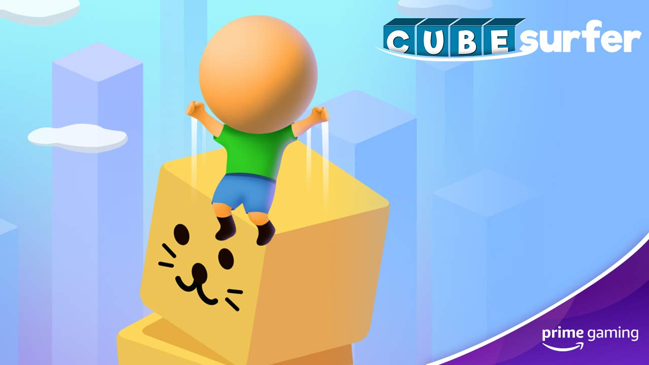 | 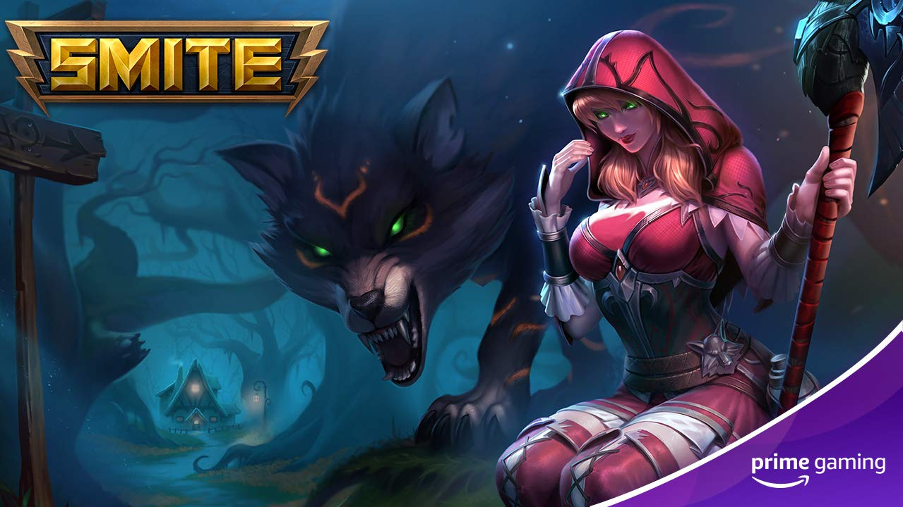
Voodoo mobile games  For a limited time, enjoy ad-free play in some of Voodoo’s wildly addicting mobile titles.  - Available March 4 – 21 days of ad-free play in Hole.io  - Available March 8 – 21 ad-free days in Aquapark.io  - Available March 11 – 7 ad-free days for Cube Surfer  - Available March 18 – 7 days of ad-free play in Helix Jump | Smite  Unlock the exclusive Fabled skin for Artio, The Bear Goddess.  Drop 6 of 9
Calendar March 2021
Now Available Apex Legends Drop 3
Now Available Fall Guys Drop 3
Now Available SMITE Drop 6
Now Available Epic 7 Drop 2
Now Available World of Tanks Drop 2
March 1 Games With Prime - Bomber Crew Deluxe, Blasphemous, SkyDrift, Boomerang Fu, Tengami
March 2 STAR WARS: Squadrons Drop 4
March 3 WAR OF THE VISIONS FINAL FANTASY BRAVE EXVIUS Drop 8
March 4 Hole.io Drop 2
March 4 Magic Tiles Drop 14
March 8 Aquapark.io Drop 4
March 8 Madden Drop 7
March 8 League of Legends Drop 7
March 9 Legends of Runeterra Drop 3
March 10 MapleStoryM Drop 3
March 10 Apex Legends Drop 4
March 10 Epic 7 Drop 3
March 11 Curb Surfer Drop 4
March 11 Darkness Rises Drop 4
March 12 Rocket Arena Drop 6
March 17 WAR OF THE VISIONS FINAL FANTASY BRAVE EXVIUS Drop 9
March 18 Helix Jump Drop 3
March 18 League of Legends Drop 8
March 18 World of Tanks Drop 3
March 19 Rainbow Six Siege Drop 4
March 22 FIFA Drop 3
March 24 Destiny 2 Drop 5
March 24 Epic 7 Drop 4
March 25 UFC Drop 3
March 29 League of Legends Drop 9
March 31 Last Chance to Claim 20+ Free SNK Games
Coming this March Alliance vs. Empire (AxE) Drop 1

For the latest on content, offers and sweepstakes, follow Prime Gaming on the official Prime Gaming blog, Twitter, Facebook and Instagram.

About Prime Gaming
With Prime Gaming, Amazon Prime members enjoy tons of exclusive content for their favorite PC, console, and mobile games. Plus, they can claim a collection of PC games for every month that are theirs to keep forever, and a monthly Twitch channel subscription. Prime Gaming’s selection of in-game content and PC games is always growing and rotating to stay fresh, with new items and free games added every month.

This is in addition to the many other benefits available with Prime, including the best of shopping and entertainment from Amazon, including fast, free delivery, along with exclusive savings, early access to deals, Prime Day, and so much more. Members enjoy unlimited streaming access to a vast collection of TV shows, movies, sports and more with Prime Video, ad-free listening of 2 million songs plus thousands of stations and playlists with Amazon Music, unlimited access to a rotating selection of more than 1,000 books and magazines with Prime Reading, and unlimited photo storage with Amazon Photos.

