Haglöfs SS19
Stockholm, January 2019
l.i.m Mountain proof anorak | lightweight & high-performing
Haglöfs’ new mountaineering jacket for SS19 features all the essentials, and nothing else. That's because the L.I.M Mountain PROOF Anorak has been built according to the L.I.M philosophy – Less Is More – where every spare gram is removed without compromising any of the functionality. It's waterproof, fits perfectly, and is built to last.
Haglöfs’ L.I.M Mountain PROOF Anorak is a new 3-layer addition to the already well-established L.I.M range and has been created in both men’s and women’s styles. It's a shell jacket for mountaineering: one that's light and extremely packable, saving space in your pack and lightening your load significantly.
The jacket is built with Haglöfs’ own PROOF™ ECO technology – developed to offer outstanding protection while, at the same time, being more sustainable, thanks to the 100% recycled polyamide used in its creation.
As Robert Olsson, Senior Clothing Designer at Haglöfs, puts it:
“The L.I.M Mountain PROOF Anorak is built to an ultra-lightweight minimal design, with every spare gram removed and none of the functionality compromised. It's a pull-over jacket that features only the essentials you need when mountaineering – plus it’s waterproof, extremely breathable, fits perfectly, and is built to last”,
The L.I.M Mountain PROOF Anorak comes in slate and mosaic blue for both men (XS-XXL) and women (XS-XXL) and will be launched in April 2019. Estimated retail price: 380€.

For more information, please contact:
Erica Wigge
Global Publishing Manager
+ 46 8 584 906 59
erica.wigge@haglofs.se

L.I.M mountain proof anorak – FACT SHEET
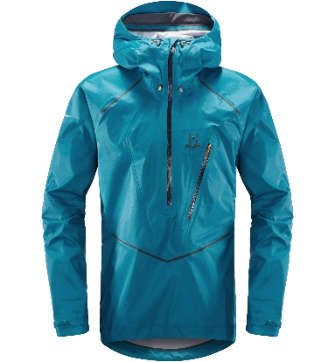
Features
- Fabric: 3-layer, PROOF™ ECO fabric. 100% recycled Polyamide, super-light yet durable, shiny, mini rip-stop face weave, laminated to a microporous PU membrane and a light low denier woven grid backer
- 68 g/ m², Hydrostatic head: >20,000 mm; Moisture Permeability (inverted cup): >20,000 g/m²/24h
- Fluorocarbon-free DWR-treated surfaces to help repel water and dirt
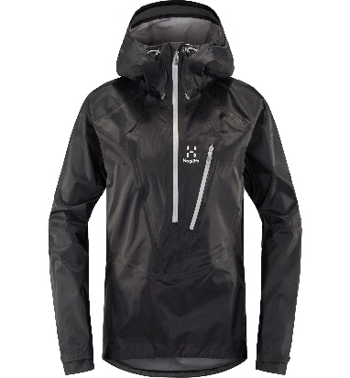
- Drawcord-adjustable bottom hem
- Velcro sleeves
- 3D-adjustable hood
- One zippered chest pocket
- Overlay tape details for seam durability
- Centre back length: 83 cm (men’s size L), and 72,5 cm (women’s size M)

