PRESS RELEASE

Pan Pacific Hotels Group Enters Tokyo, Japan in 2020
With Cerulean Tower Tokyu Hotel, a Pan Pacific Partner Hotel

11 December 2019, Singapore – Pan Pacific Hotels Group has signed an agreement to enter Tokyo, Japan to market the five-star Cerulean Tower Tokyu Hotel as a Pan Pacific Partner Hotel through its distribution channels and its loyalty programme, Pan Pacific DISCOVERY.
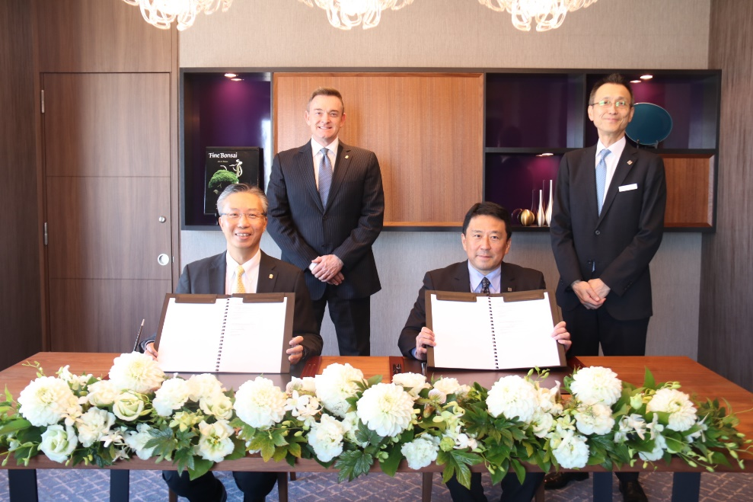
[Seated in front row from left to right] Mr Choe Peng Sum, Chief Executive Officer, Pan Pacific Hotels Group;
Mr Yoshiaki Miyajima, General Manager, Cerulean Tower Tokyu Hotel and Managing Executive Officer, Tokyu Hotels Co., Ltd. [Standing in back row from left to right] Mr Kevin Croley, Senior Vice President, Business Development, Pan Pacific Hotels Group; Mr Sanrokyu Yamanaka, Rooms Director, Cerulean Tower Tokyu Hotel

Mr Choe Peng Sum, Chief Executive Officer, Pan Pacific Hotels Group, said, “We are proud to partner the Cerulean Tower Tokyu Hotel as a Pan Pacific Partner Hotel as an international presence. Through our loyalty programme Pan Pacific DISCOVERY, the hotel will have access to 15.6 million members worldwide.”
“We have a long-standing relationship with Pan Pacific Hotels Group. Over the years, we have maintained close links to the Group and collaborated on numerous occasions. Now, we are delighted to elevate this partnership to new levels as their first Pan Pacific Partner Hotel. We are excited to be the first property in Japan to join the Pan Pacific DISCOVERY network, and look forward to welcoming DISCOVERY members from the world over to our city,” added Mr Yoshiaki Miyajima, General Manager, Cerulean Tower Tokyu Hotel Co., Ltd and Managing Executive Officer, Tokyu Hotels Co., Ltd.
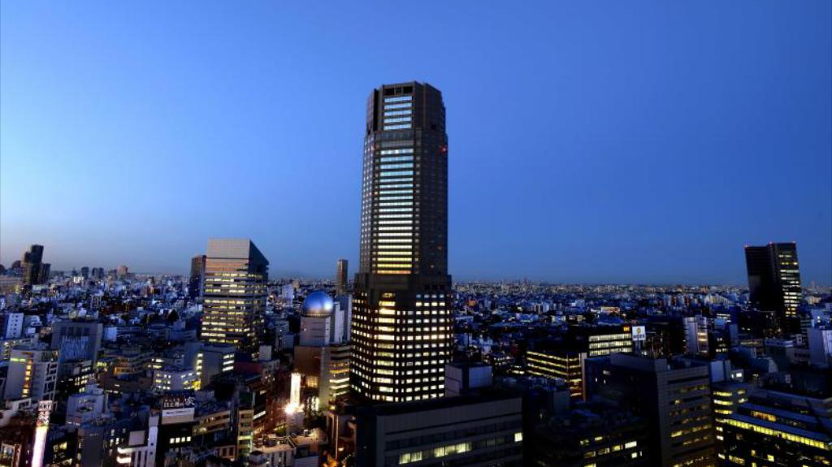
Cerulean Tower Tokyu Hotel, a Pan Pacific Partner Hotel
Towering at 188 metres, Cerulean Tower Tokyu Hotel, a Pan Pacific Partner Hotel, dominates the skyline of Tokyo’s trendy Shibuya. It offers guestrooms which are unusually spacious in this city. Spread over 40 floors, all 411 rooms open up to unobstructed views of the glittering nightscape and Mount Fuji on clear days.
The hotel is an oasis of elegant comfort in one of Tokyo’s liveliest areas. It is surrounded by the famous Shibuya Crossing, Shibuya train station, Hachiko Memorial Statue and Taito business district. Shopping opportunities abound in Shibuya and adjacent Shinjuku and Ginza, both just one train station away.
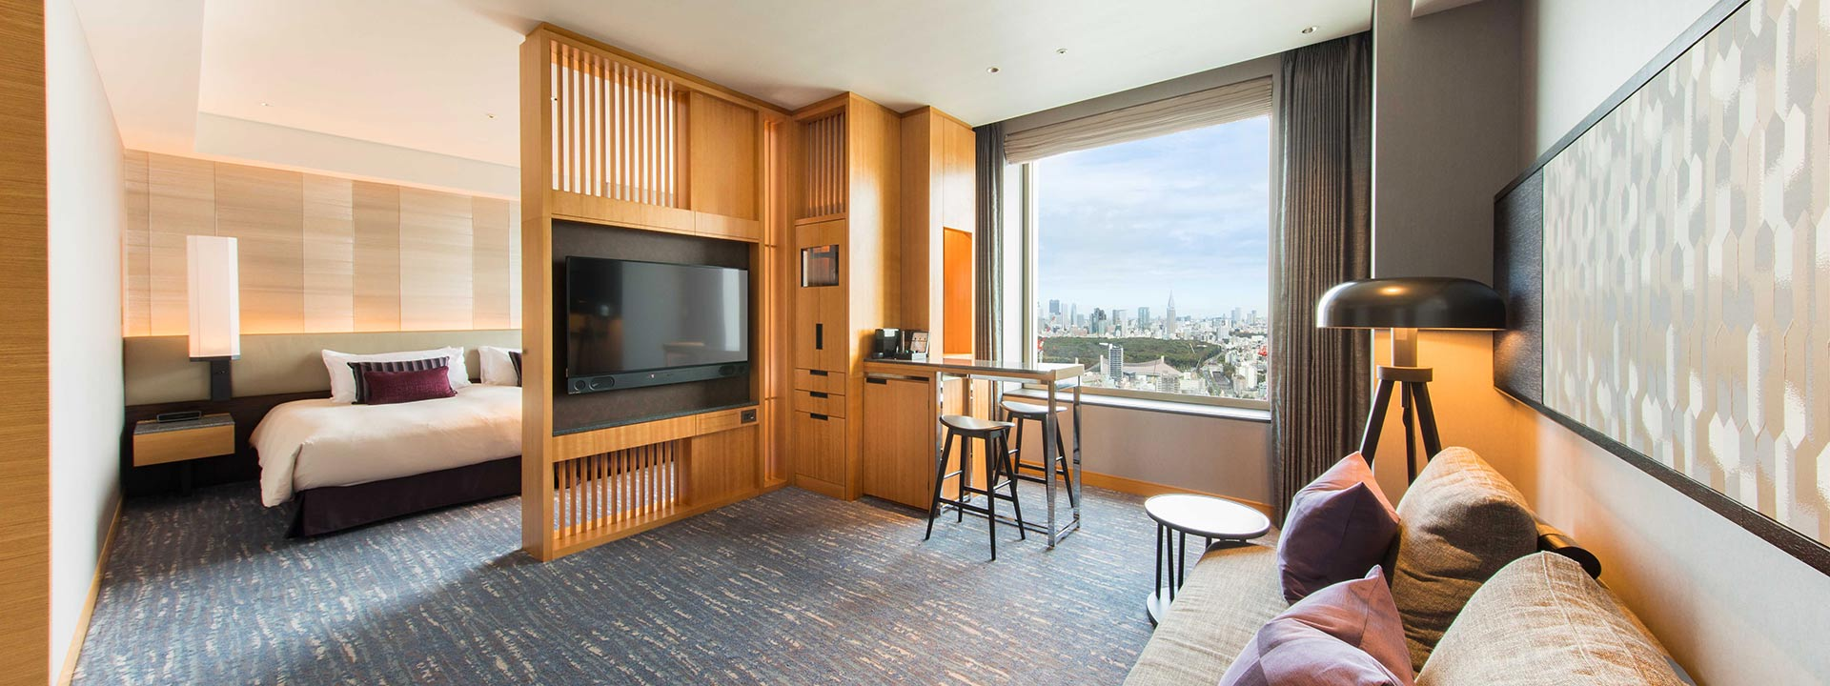
Guestrooms are located from the 19th floor, offering spectacular views of the city skyline
For a more reflective experience, Yoyogi Park is a 15-minute walk away. It is one of Tokyo’s largest city parks popular for its cherry blossoms in spring and gingko trees which turn golden in autumn. Continue walking for another 10 minutes and one will reach the Meiji Jingu (Meiji Shrine) and its ancient forest of more than 120,000 trees.
The hotel caters to diverse palates with eight excellent F&B outlets, including the beautiful Kanetanaka-So, its Japanese fine-dining restaurant. Perched on the top floor are elegant French restaurant Coucagno, helmed by Chef Nagatsuma who has honed his craft in a two Michelin-starred restaurant in France, as well as Bellovisto, a glamourous piano bar. Chef Kenichi Chen of Iron Chef fame holds fort at CHEN Chinese restaurant, which is known for its authentic Szechuan cuisine, while JZ Brat Sound of Tokyo, a 100-seat jazz club, has an avid following with its incredible live jazz performances.
A comprehensive suite of wellness facilities, including an indoor heated pool with natural lighting, a large Japanese-style sauna, and modern gym. A beauty salon, nursery and dental clinic ensure that every conceivable need is taken care of. In addition, the hotel houses an art gallery, a lounge offering French pastries and curated Japanese teas overlooking an outdoor garden, a florist and the Noh Theatre, the only hotel theatre in the city which hosts ballet, opera, and noh, the oldest surviving form of Japanese theatre art.
Three-time winner of “Best Regional Hotel Chain”, Pan Pacific Hotels Group operates the Pan Pacific and PARKROYAL brands in 29 key cities worldwide. In 2020, the Group will open its luxury flagship Pan Pacific London, its first PARKROYAL hotel in Dalian, China, and PARKROYAL COLLECTION Marina Bay, which will offer a fresh concept around a “garden in a hotel” after its rebrand.
-ENDS-
Media Contact
Cuili NG
Director, Brand & Corporate Communications
Pan Pacific Hotels Group
Mobile: +65 9634 4425
Email: ng.cuili@pphg.com

About Pan Pacific Hotels Group
Pan Pacific Hotels Group is a member of Singapore-listed UOL Group Limited, one of Asia’s most established hotel and property companies with an outstanding portfolio of investment and development properties.
Based in Singapore, Pan Pacific Hotels Group owns and/or manages nearly 50 hotels, resorts and serviced suites including those under development in 29 cities across Asia, Oceania, North America and Europe.
Voted “Best Regional Hotel Chain” by readers in Asia from 2017 to 2019, Pan Pacific Hotels Group comprises three brands: Pan Pacific, PARKROYAL COLLECTION and PARKROYAL.
Sincerity is the hallmark of Pan Pacific Hotels Group. The Group is known to its guests, partners, associates and owners for its sincerity in people and the sense of confidence which alleviates the stresses of today’s complex world.
Visit us at www.panpacific.com.
Pan Pacific Hotels and Resorts
With hotels, resorts and serviced suites across Asia, Oceania and North America, Pan Pacific provides a safe harbour in an ever-changing world. Places with less to worry about because, when you stay with us, rest assured that all will be taken care of. For this is where you will find your balance.
About Global Hotel Alliance
Global Hotel Alliance (GHA) is the world’s largest alliance of independent hotel brands, bringing together more than 30 brands with over 550 hotels in 78 countries. GHA uses a shared technology platform to drive incremental revenues and create cost savings for its member brands. GHA’s award-winning loyalty programme, DISCOVERY, provides 15 million members exclusive opportunities to immerse themselves in local culture wherever they travel. For more information, visit www.globalhotelalliance.com.

