FOR IMMEDIATE RELEASE

Intellian’s v85NX antenna system gains
Telenor Satellite Thor 7 type approval
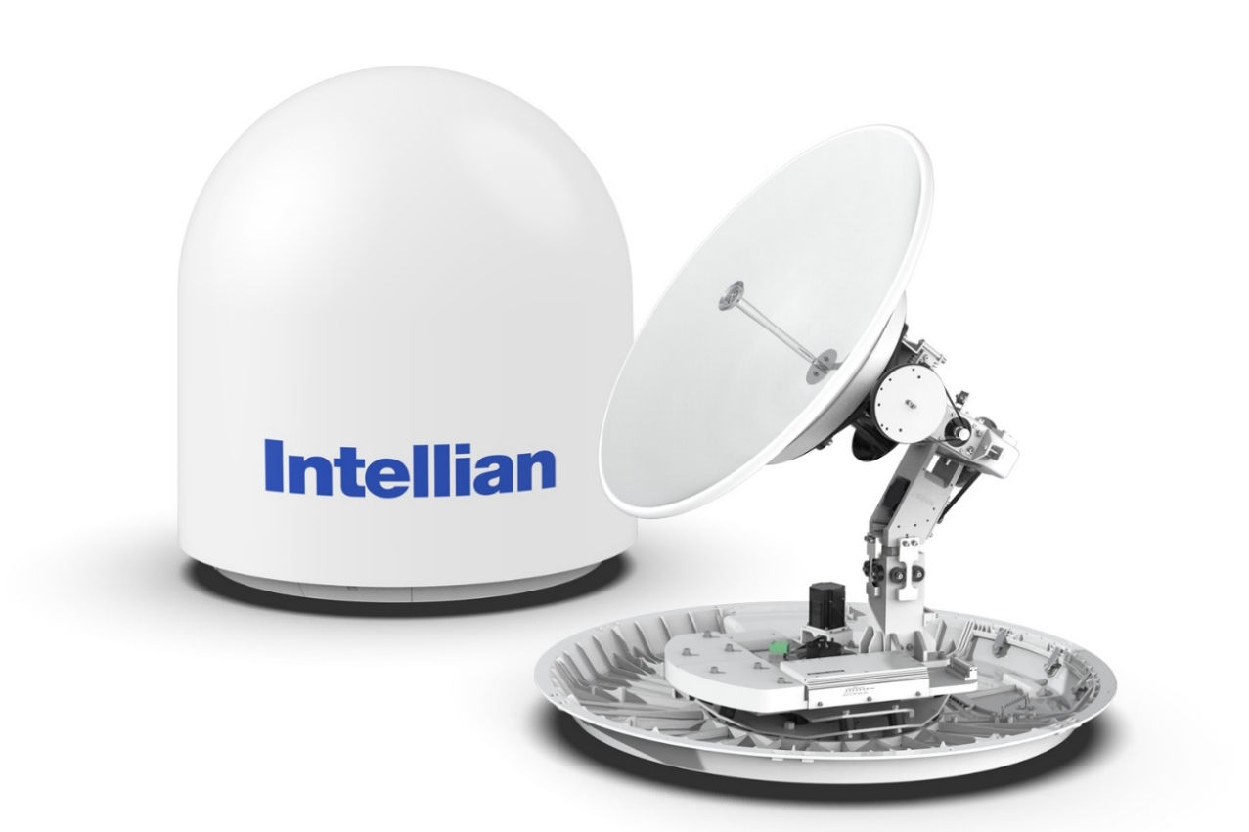

Following successful sea trials, Telenor Satellite have approved Intellian’s v85NX antenna for use with their Thor 7 Ka-band GEO satellite

20 May 2020 – Intellian is delighted to announce that its v85NX antenna has earned type approval for Telenor Satellite’s Thor 7 Ka-band service, following successful sea trials. Significantly the v85NX – which is the first 85cm antenna to be certified on the Thor 7 network – will benefit from the same airtime pricing as 1m antennas. As service provision for smaller antennas is usually more expensive owing to their lower gain, this recognizes the outstanding performance of the v85NX and makes it a competitive choice for customers looking for a compact design with low capital and operational expenditure.
Offering up to 25 simultaneously active spot beams, the Thor 7 service is designed to provide optimal HTS Ka-band VSAT connectivity across Europe, covering busy shipping lanes in the North Sea, Norwegian Sea, Barents Sea, Baltic Sea and Mediterranean Sea. Jan Hetland, Director, Data Service Division at Telenor Satellite, said: “We’re delighted to welcome Intellian’s v85NX antenna to our leading Thor 7 service. A satellite service providing high-powered performance for maritime applications requires premium hardware, and Intellian’s NX Series systems have a range of attributes which position them at the forefront of antenna technology, reflecting Telenor Satellite’s forward-looking service provision. We look forward to working together in delivering outstanding global communications to our loyal customers.”
The RF design of NX Series antennas outperforms rival products, resulting in unmatched data rates. A major advantage is that dual antennas – often employed to avoid the satellite being obstructed by vessel superstructure – may be easily configured thanks to the mediator built into the ACU. Before, a separate mediator unit was required. The antennas can be easily converted between Ku- and Ka-band by swapping out the center-mounted RF assembly and feed, and there is also a range of BUC options – 5W and 10W for Ka-band and from 8W to 25W for Ku-band – which are interchangeable with no need to rebalance the system following their installation.
Eric Sung, Intellian CEO, commented: “This certification from Telenor Satellite, and the competitive price bracket in which Telenor has placed the v85NX, underlines the performance and versatility of our NX Series antennas. New customers can purchase a v85NX antenna pre-configured for Ka-band off the shelf, while users who already own a v85NX antenna on a Ku-band network can easily convert it to Ka-band operation for use with Thor 7. We are delighted to join with Telenor in facilitating flexible, high-speed communications across Europe.”
NX Series antennas are shipped pre-slung to facilitate installation, and the use of modular components common to the entire antenna range has cut the number of spare parts required by up to 40%. This in turn simplifies maintenance, enhances reliability and brings about further cost savings for end users.

-Ends-

About Intellian Technologies, Inc.
Intellian is the global leader of mobile satellite communication systems for maritime applications and a leading communication technology innovator for the government, military, energy, cruise and enterprise sectors. Founded in 2004, Intellian continues to invest in cutting-edge design, R&D, Quality Control, and advanced low environmental impact production facilities to deliver bold and pioneering solutions. These include the award-winning v240MT, the world’s first tri-band, multi-orbit antenna system and the future-proof NX series antennas optimized for high performance and low cost of ownership.

Intellian has a global presence with over 400 employees, 12 regional facilities and 5 logistics centers on 3 continents. The Intellian 24/7 global support desk provides dedicated assistance to 550 service provider partners and their customers in mission critical environments. Intellian Technologies Inc. is listed on the Korean Stock Exchange, KOSDAQ (189300:KS).

More information may be found at www.intelliantech.com.

About Telenor Satellite
Telenor Satellite is a major EMEA satellite provider of broadcast and data communication services in the broadcast, maritime, and oil and gas markets. Using a hybrid network that comprises a fleet of three satellites located at 1° West, teleports and a terrestrial fiber network, Telenor Satellite provides reliable communications in remote locations on land and at sea.

Telenor Satellite is headquartered at Telenor Group offices in Fornebu, Oslo, with the teleport located in Nittedal. The company is 100% owned by Telenor Broadcast Holding AS, a holding company of Telenor Group.

Further information is available at www.telenorsat.com.

For further enquiries, please contact:
Paul Comyns / VP of Marketing
Intellian Technologies USA
T + 1 949 727 4498 ext. 1301
Paul.Comyns@intelliantech.com

David Pugh
Saltwater Stone
T +44 1202 669 244
d.pugh@saltwater-stone.com
Sadie Brown / Marketing Manager
Intellian Ltd
T +44 2380 019 021 ext. 1612
Sadie.Brown@intelliantech.com

