LK releases this year Sustainability Report
The report describes all aspects of our sustainability work. The hope is that this report will increase awareness and provide inspiration for further sustainable initiatives, both in-house and externally.

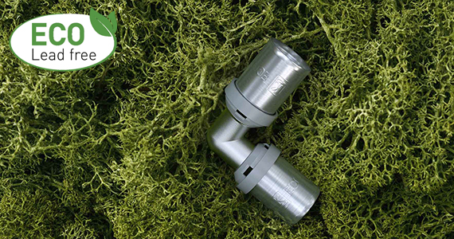

LK has chosen to report on sustainability at group level, despite the fact that only one subsidiary is subject to legal requirements to do so. This work is stimulated by the new brand platform, with all group companies now gathered under the joint LK brand, providing a clearer overall picture of sustainability issues. Together, we can develop the business so that both interim goals and overall goals can be attained more effectively.

– The Sustainability Report will help us to ask questions of ourselves and take the appropriate action. It highlights the things we do well, as well as areas where there is room for improvement. It reinforces our resolve not to rest on our laurels or continue working along the same old lines. We work on a day-to-day basis to achieve increased sustainability for our customers, ourselves and the environment, says Michael Söderberg, CEO, Water and Heating Systems.

The Sustainability Report is divided into three sections; respect for human rights and combating corruption, environmental sustainability, and corporate social responsibility and staff.

– We have during 2019 introduced a new lead-free product series, LK Unicersal ECO. The LK Universal Eco product series is manufactured from dezincification resistant lead-free brass and comprises press fittings, manifolds and wall boxes that are used for HVAC installations. We are constantly trying to reduce the environmental impact of our products, and plan to expand the lead-free range gradually, says Michael Söderberg.

Download the full Sustainability Report.

For the simpler, smarter everyday
Simpler. Smarter. More sustainable. At LK, we believe there’s a better way to do everything. That’s why – from water, heating and hydronic solutions to pipe extrusion and marine flow control – we push for innovation over status quo and simplicity over complexity. It’s a belief all of us at LK apply to every product and solution we create.

