RUFUS WAINWRIGHT
Announces European “Unfollow the Rules Tour”

The London Times’ 4 star review of his London Palladium show comments “when he unleashes that velvety truffle of a voice…you want it to go on and on.”
Photo by Carsten Windhorst
More photos here: https://www.dropbox.com/t/MWtLQerepujeFEUn

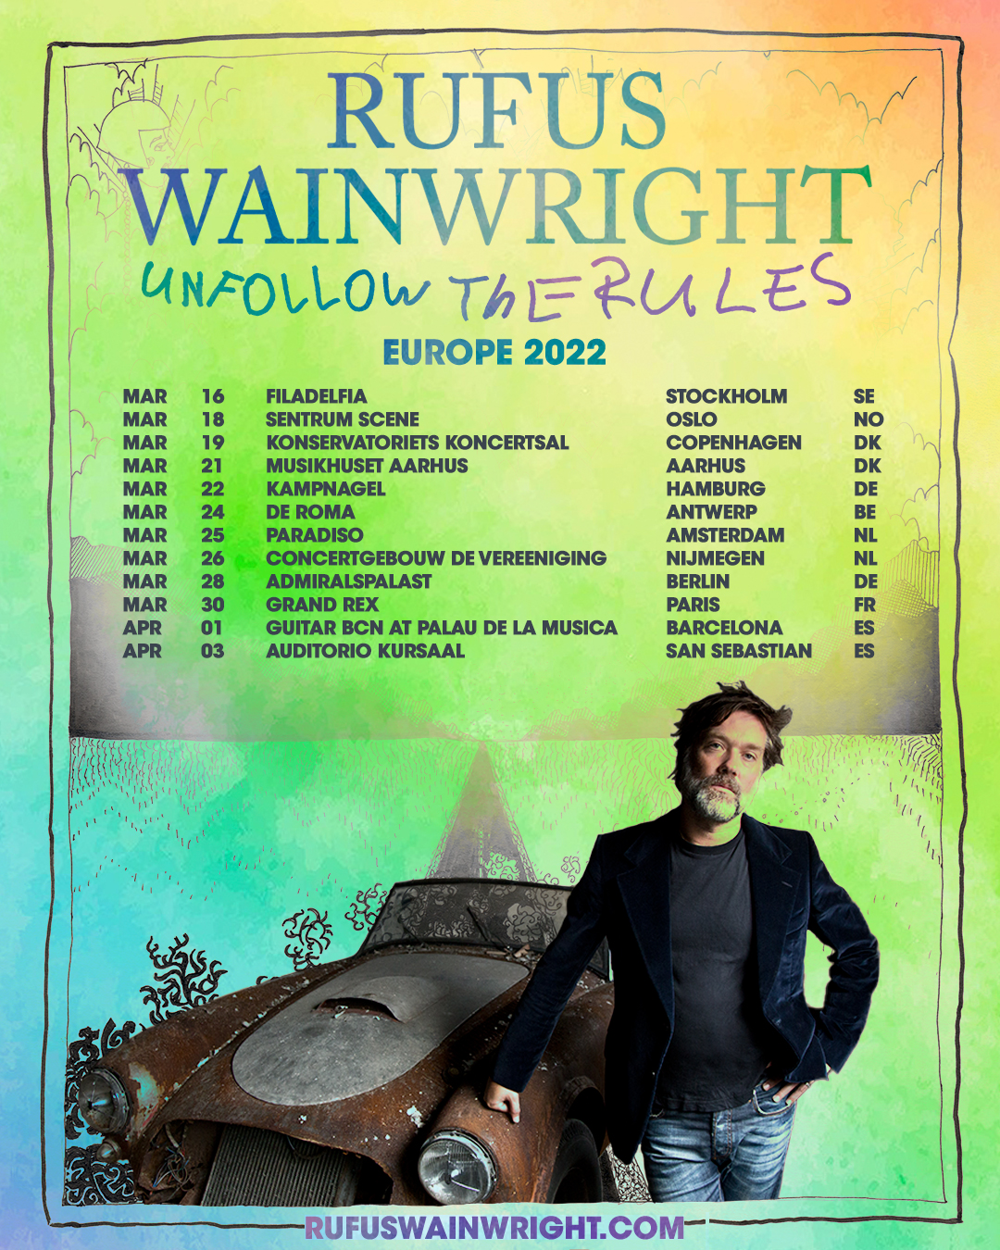
On the heals of a successful UK band tour, Rufus Wainwright announces a European tour that brings him and his band to Scandinavia, Belgium, Netherlands, Germany, France and Spain from March 16th through April 3rd 2022.

The tour is in support of his 2020 BMG released Grammy-nominted pop album UNFOLLOW THE RULES. Since then Rufus has released another album with BMG and a second is slated to be released later this year. “Unfollow the Rules – Paramour Session” released in September 2021 is a live recording of a stripped down version of Unfollow the Rules plus some new tracks recorded and filmed in Los Angeles prior to the studio album’s release and “Rufus Wainwright and Amsterdam Sinfonietta” is a live recording of a 2017 tour with the famed Amsterdam based 21 piece string orchestra featuring covers of Jacques Brel, Joni Mitchell, Leonard Cohen plus Wainwright classics and previously unreleased songs in lush new arrangements.

Known for his incredibly engaging live performances, Rufus returns to Europe with a brand new band for the tour: LA musician Brian Green (John Legend, Michael Bublé, Pomplamoose) as music director, guitar and backing vocals; Jacob Mann on keyboard, piano and backing vocals; and Alan Hampton on bass, guitar, ukulele and backing vocals.
Playing a set list of classics and new cuts from his highly anticipated new album, the dates are sure to be one of the highlights of the year. General tickets will be on-sale at 10am CET on Friday, October 29 HERE

Speaking of the tour Rufus said ‘I am excited to tour Europe with Unfollow the Rules. I have always felt very much at home artistically there and my husband and I actually have a home in Berlin so I get to spend some time there and even play his home town. A lot of my musical references have European roots. I consider Unfollow the Rules my first fully mature album; it is like a bookend to the beginning of my career.” He continues ‘For me with every concert that is happening, mine or others we are returning a bit more towards our normal lives. Experiencing music together gives me hope and confidence that we will rise above the isolating and heartbreaking experience of the past two years collectively’.

Rufus Wainwright plays the following in Europe this coming March and April.

Wednesday, March 16, 2021 - Filadelfia - Stockholm, Sweden
Friday, March 18, 2021 - Sentrum Scene - Oslo, Norway
Saturday, March 19, 2021 - Konservatoriets koncertsal - Copenhagen, Denmark
Monday, March 21, 2021 - Musikhuset Aarhus - Aarhus, Denmark
Tuesday, March 22, 2021 - Kampnagel - Hamburg, Germany
Thursday, March 24, 2021 - De Roma - Antwerp, Belgium
Friday, March 25, 2021 - Paradiso - Amsterdam, Netherlands
Saturday, March 26, 2021 - Concertgebouw De Vereeniging - Nijmegen, Netherlands
Monday, March 28, 2021 - Admiralspalast - Berlin, Germany
Wednesday, March 30, 2021 - Le Grand Rex - Paris, France
Friday, April 1, 2021 - Guitar Bcn at Palau de la Musica - Barcelona, Spain
Sunday, April 3, 2021 - Auditorio Kursaal - San Sebastian, Spain

Wainwright’s ninth studio LP and first new pop album since 2012, UNFOLLOW THE RULES finds the artist at the peak of his powers, entering artistic maturity with passion, honesty, and a new-found fearlessness while remaining as creative, bold, and mischievous as ever.

Produced by Mitchell Froom (Crowded House, Paul McCartney, Richard Thompson, Suzanne Vega, Randy Newman) at a variety of legendary Los Angeles studios – including Sound City Studios, United Recording, and EastWest Studios – the album serves as both bookend to Act I of an extraordinary career which, like Unfollow The Rules, began in the studios of Los Angeles, but also now as the first lines of a remarkable new chapter.

The press found overwhelming praise for Wainwright’s 9th studio album:

“An opulently crafted highlight reel, a career-spanning sampler of the singer’s many styles and guises.” - Pitchfork

“Nobody sings quite like Rufus Wainwright.” - The New Yorker

“‘Unfollow The Rules’ showcases Wainwright’s skills in the highest definition.” - Mojo

“Lush, layered, romantic, passionate, feverish and febrile...Wainwright is the man.” - Financial Times UK

“If this was the first Rufus Wainwright album you ever heard, it would surely seduce you as effortlessly as any he’s made.” - Metro

“‘Unfollow The Rules’ is a timely reminder of everything that’s wonderful about Wainwright.” - Clash

“Rufus Wainwright has always been a daredevil, but his new album is still a shock...this is one of Wainwright’s finest albums.” - Independent

About Rufus Wainwright

Praised by the New York Times for his “genuine originality,” Rufus Wainwright has established himself as one of the great male vocalists, songwriters, and composers of his generation. The New York-born, Montreal-raised singer-songwriter has released ten studio albums to date, three DVDs, and three live albums including the Grammy-nominated Rufus Does Judy at Carnegie Hall. He has collaborated with artists such as Elton John, Burt Bacharach, Robert Wilson, David Byrne, Boy George, Joni Mitchell, Pet Shop Boys, Heart, Robbie Williams, Jessye Norman, Billy Joel, Paul Simon, Sting, and producer Mark Ronson, among many others. He has written two operas, numerous songs for movies and TV, and is currently working on his first musical. His latest GRAMMY® and JUNO nominated album, Unfollow the Rules, finds Wainwright at the peak of his powers, entering artistic maturity with passion, honesty, and a new-found fearlessness.

Order ‘UNFOLLOW THE RULES’ HERE
Order “Unfollow the Rules The Paramour Session” HERE
Pre-order “Rufus Wainwright + Amsterdam Sinfonietta” HERE

OFFICIAL
FACEBOOK
YOUTUBE
TWITTER
INSTAGRAM

For further press inquiries please contact breakersmanagement@gmail.com

