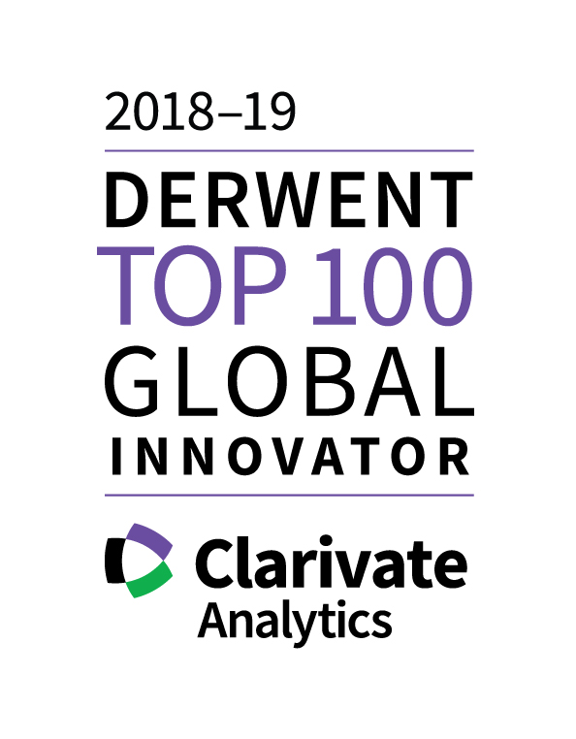
Epson Named Among Top 100 Global Innovators for Eighth Consecutive Year
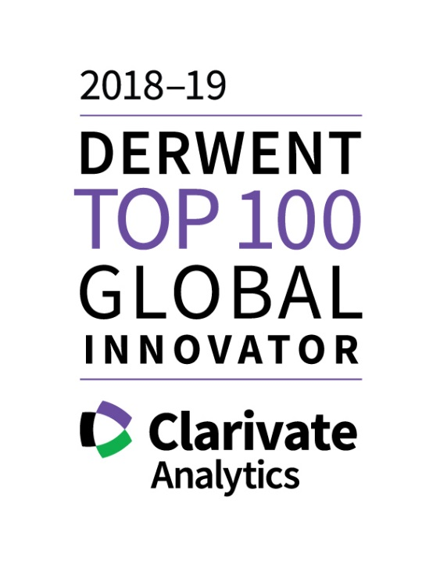

- TOKYO, Japan, January 23, 2019 –

Seiko Epson Corporation (TSE: 6724, "Epson") has been listed among the Derwent Top 100 Global Innovators 2018-19 announced by Philadelphia-based Clarivate Analytics. Epson has been named to the list every year since its inception in 2011.
Reasons for selection (cited by Clarivate Analytics)

Seiko Epson is again recognised this year as one of the 2018-19 Derwent Top 100 Global Innovators. They are also amongst the best of the best being one of only 35 organizations to have been recognised for the eighth year in a row since the inception of the program in 2011. These innovators exhibit consistently strong performance in successfully obtaining rights to their innovation, seeking wide protection and global markets for potential products and services based on that innovation and are recognized by their peers as creating leading innovation for others to build on.
Seiko Epson regularly files high volumes of patent applications and had good success this year in converting these to granted patent rights. They also showed improved performance in global filing of inventions filing more within the Quadrilateral authorities (US, Japan, China and Europe) than last year. Congratulations to Seiko Epson on achieving this prestigious recognition again this year!

Intellectual property at Epson
Epson holds as many as patents globally and is working with patent agencies in 20 countries or more at any given time. In the patent rankings for 2017, Epson ranked 9th in Japan for the number of patents awarded, 22nd in the U.S., and 16th in China (among foreign companies). In projectors and inkjet printers, where Epson continuously strives to refine its core technologies, the company is among the leaders in the industry in terms of patent quantity and quality. Epson is proud to call itself a world-class IP company.

“It is an honor to be selected as one of the Top 100 Global Innovators for the eighth consecutive year,” said Toshiya Takahata, executive officer and general administrative manager of Epson's Corporate Planning Division and Intellectual Property Division. “Based on our Epson 25 corporate vision, we closely align our business and intellectual property strategies, and focus on acquiring high-quality patents that will contribute significantly to our business. We therefore believe that award criteria are important indicators of the success of our strategy, and take this award as evidence of the quality and global reach of our intellectual property. As stated in its Management Philosophy, Epson seeks to become an indispensable company, an ambition that Epson considers to be consistent with the realization of the sustainable development goals (SDGs) of the United Nations. We will continue to conduct our business and pursue intellectual property activities with the aim of creating a sustainable society.”

Top 100 Global Innovators
Clarivate Analytics analyzes intellectual property and patent trends based on proprietary data to determine the world's most innovative corporations and institutions. The analysis covers four main criteria: patent volume, success, globalization, and influence. Begun in 2011, the Top 100 Global Innovators report is now in its eighth year.
For details, please see the Clarivate Analytics press release.
https://clarivate.com/
For more details about Epson's intellectual property activities, click on the link below.
global.epson.com/innovation/intellectual_property/

About Epson
Epson is a global technology leader dedicated to connecting people, things and information with its original efficient, compact and precision technologies. With a lineup that ranges from inkjet printers and digital printing systems to 3LCD projectors, watches and industrial robots, the company is focused on driving innovations and exceeding customer expectations in inkjet, visual communications, wearables and robotics.
Led by the Japan-based Seiko Epson Corporation, the Epson Group comprises more than 81,000 employees in 85 companies around the world, and is proud of its contributions to the communities in which it operates and its ongoing efforts to reduce environmental impacts.
global.epson.com/

