Kongsberg Maritime wins contract with Myklebust Verft to deliver innovative low-emission LFC for Sølvtrans
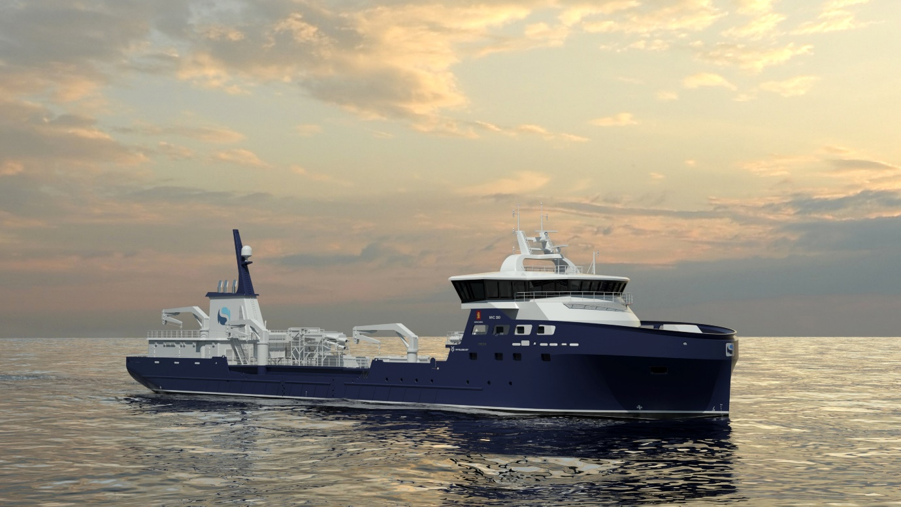Kongsberg Maritime is to design and equip a low-emission LFC for fish transportation specialist Sølvtrans
Kongsberg, Norway, 2nd March 2021 – Kongsberg Maritime (KM) is delighted to announce that it has signed a NOK 70 million contract with Norwegian shipyard Myklebust Verft to design and equip a new Live Fish Carrier (LFC) for live fish transportation company Sølvtrans. In support of this and their long-standing collaboration, Sølvtrans has also signed a Long-Term Service Agreement (LTSA) with KM for maintenance of their fleet.
The new 5,000m³ LFC will be built to KM’s new NVC 390 design, with a clear focus on reduced emissions and enhanced sustainability. This is reflected by the comprehensive KONGSBERG equipment package, which includes Promas propulsion, generators, thrusters, electrical systems and automation. To date, KM has designed eight LFCs for Sølvtrans, with six previously built or under construction at Myklebust Verft.
With its headquarters in Ålesund on Norway’s west coast, Sølvtrans is the world’s largest LFC company for the transportation of live salmon and trout, with plans to invest up to NOK 7 billion on 18 newbuild vessels by 2025. Sølvtrans has more than 30 years’ experience in the operation of LFCs, pioneering the use of a humane and cost-effective closed system technology for the transportation and handling of live fish which greatly reduces the potential spread of infectious diseases.
“We greatly appreciate the collaboration we have developed with Sølvtrans and Myklebust,” says Monrad Hide, Sales Director in Ship Design, Kongsberg Maritime. “Sølvtrans’ determination to promote humane, environmentally-friendly operation is entirely consistent with KONGSBERG’s mission to incorporate sustainability in everything we do, and this cooperation has had major positive ripple effects in our region.”
The new LTSA comes following a market challenge by Sølvtrans to KM on product life cycle management, account management and quality of service. “These factors are equally as important to Sølvtrans as the investment cost of their new build,” says Leif Johnny Ulleland, Sales Manager, Aftermarket Sales, Kongsberg Maritime, “and are now included in our new LTSA.” The LTSA cements Kongsberg Maritime’s position as equipment supplier to the combined fleet of 25 vessels operated by Sølvtrans and Sølvtrans Chile, which can be found plying the waters of Norway, Canada, Scotland, Chile and Tasmania.
“We are pleased to strengthen and build on our relationship with Kongsberg Maritime, both through commissioning this new LFC and confirming our business link for the future through signing an LTSA,” said Roger Halsebakk, CEO, Sølvtrans. “KONGSBERG has been a trusted partner for many years, and we look forward to continuing to work together to ensure that our vessels operate as sustainably, humanely and efficiently as possible.”
“We have enjoyed a long and close collaboration with Sølvtrans, servicing their vessels and supporting their daily operations,” concludes Ulleland. “Looking forward, we are now working on improving their dock planning, upgrading their battery options, examining digitalisation opportunities and setting them up for remote access.”
Ends

For further information, please contact:
Gunvor Hatling Midtbø, VP Communication
Kongsberg Maritime
Tel: +47 9921 4209
gunvor.hatling.midtbo@km.kongsberg.com
David Pugh
Saltwater Stone
Tel: +44 (0)1202 669244
d.pugh@saltwater-stone.com

About Kongsberg Maritime
Kongsberg Maritime is a global marine technology company providing innovative and reliable ‘Full Picture’ technology solutions for all marine industry sectors including merchant, offshore, cruise, subsea and naval. Headquartered in Kongsberg, Norway, Kongsberg Maritime has manufacturing, sales and service facilities in 34 countries.
Kongsberg Maritime solutions cover all aspects of marine automation, safety, manoeuvring, navigation, and dynamic positioning as well as energy management, deck handling and propulsion systems, and ship design services. Subsea solutions include single and multibeam echo sounders, sonars, AUV and USV, underwater navigation and communication systems.
Training courses at locations globally, LNG solutions, information management, position reference systems and technology for seismic and drilling operations are also part of the company’s diverse technology portfolio. Additionally, Kongsberg Maritime provides services within EIT (Electro, Instrument & Telecom) engineering and system integration, on an EPC (Engineering, Procurement & Construction) basis.
Kongsberg Maritime is part of Kongsberg Gruppen (KONGSBERG), an international, knowledge-based group that celebrated 200 years in business during 2014. KONGSBERG supplies high-technology systems and solutions to customers in the oil and gas industry, the merchant marine, and the defence and aerospace industries.
Web: Kongsberg Gruppen | Kongsberg Maritime
Social media: LinkedIn | Twitter | Facebook

