Online exchange of the President of TH Wildau with the Palestinian Al-Quds University
(EN Version below)
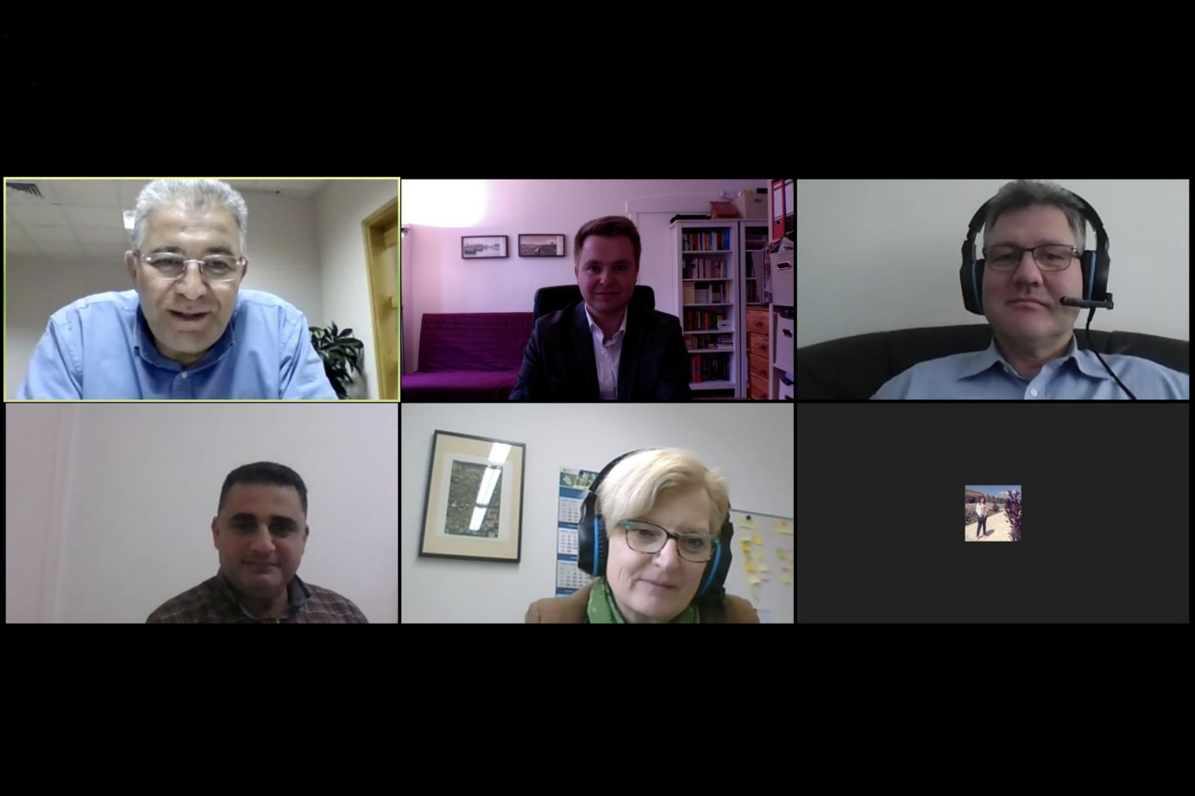
Bildunterschrift: Video conference of the President of the TH Wildau with the Al-Quds University on November 19, 2020.
Bild: TH Wildau / Görbert
Subheadline: International
Teaser:
On November 19, 2020, the President of the Technical University of Applied Sciences Wildau exchanged views with the President of the Palestinian Al-Quds University in Jerusalem. Both universities intend to sign an official cooperation agreement in the near future and to initiate further joint projects in research, transfer, and teaching.
Text:
On November 19, 2020, the President of the Technical University of Applied Sciences Wildau (TH Wildau), Prof. Dr. Ulrike Tippe, together with Prof. Dr. Marcus Frohme from the Faculty for Engineering and Natural Sciences and Dr. Johannes Görbert from the Centre for International Affairs, exchanged views with Al-Quds University in Jerusalem. From the Palestinian side, the President of Al-Quds, Prof. Dr. Imad Kishek, and Prof. Dr. Ahmad Amro, Dean of the Faculty of Pharmacy, participated.
Starting points: Cooperation in the life sciences and visit of the President to Wildau
Prof. Amro and Prof. Frohme have been working together in joint laboratory projects for quite some time. Prof. Amro, who received his doctorate in microbiology at the Charité in Berlin in 2009, has already completed three research stays at the TH Wildau, most recently last year.
During this stay in 2019, President Prof. Kishek also visited TH Wildau for the first time and met with the President and the Vice President for Research and Transfer, among others. Originally, return visits to Jerusalem were planned for this year, which unfortunately could not be realised due to the pandemic.
Further points of reference: Dual studies, transfer, artificial intelligence
Linkages to the first visit of the President to Wildau in 2019 quickly became clear also in this year's online format. A pilot project on the topic of dual studies has been running at Al-Quds University since 2015. Supported by the Deutsche Gesellschaft für Internationale Zusammenarbeit (GIZ) and the Baden-Württemberg Dual Cooperative State University, among others, it aims to increase the practical and application orientation of the study programmes Electrical Engineering, Information Technology, Business Administration and Industrial Engineering. The TH Wildau is also planning to participate in this project in the future. Prof. Frohme offered Al-Quds University, in addition to his research, further support in transfer activities, especially with regard to startups, patenting and standardisation.
Thematically, both universities see further potential for joint projects, in addition to the life sciences, especially in the field of artificial intelligence. Both university administrations confirmed their intention to continue their cooperation in the near future on the basis of an official cooperation agreement. If possible, personal meetings are to take place again next year, both on site in Wildau or at Al-Quds and on the occasion of the 30th anniversary of the TH.
Further information:
Centre for International Affairs at TH Wildau: https://en.th-wildau.de/university/central-departments-and-facilities/centre-for-international-affairs/
Homepage of Al-Quds University (English/Arabic): https://www.alquds.edu/en
Contact Person Centre for International Affairs:
Dr. Johannes Görbert
Centre for International Affairs
TH Wildau
Hochschulring 1, 15745 Wildau
Tel. +49 (0) 3375 508 851
Email: johannes.goerbert@th-wildau.de
Contact Persons Press and Media Communication:

Mike Lange / Mareike Rammelt
TH Wildau
Hochschulring 1, 15745 Wildau
Tel. +49 (0)3375 508 211 / -669
Email: presse@th-wildau.de

Online exchange of the President of TH Wildau with the Palestinian Al-Quds University

Bildunterschrift: Video conference of the President of the TH Wildau with the Al-Quds University on November 19, 2020.
Bild: TH Wildau / Görbert
Subheadline: International
Teaser:
On November 19, 2020, the President of the Technical University of Applied Sciences Wildau exchanged views with the President of the Palestinian Al-Quds University in Jerusalem. Both universities intend to sign an official cooperation agreement in the near future and to initiate further joint projects in research, transfer, and teaching.
Text:
On November 19, 2020, the President of the Technical University of Applied Sciences Wildau (TH Wildau), Prof. Dr. Ulrike Tippe, together with Prof. Dr. Marcus Frohme from the Faculty for Engineering and Natural Sciences and Dr. Johannes Görbert from the Centre for International Affairs, exchanged views with Al-Quds University in Jerusalem. From the Palestinian side, the President of Al-Quds, Prof. Dr. Imad Kishek, and Prof. Dr. Ahmad Amro, Dean of the Faculty of Pharmacy, participated.
Starting points: Cooperation in the life sciences and visit of the President to Wildau
Prof. Amro and Prof. Frohme have been working together in joint laboratory projects for quite some time. Prof. Amro, who received his doctorate in microbiology at the Charité in Berlin in 2009, has already completed three research stays at the TH Wildau, most recently last year.
During this stay in 2019, President Prof. Kishek also visited TH Wildau for the first time and met with the President and the Vice President for Research and Transfer, among others. Originally, return visits to Jerusalem were planned for this year, which unfortunately could not be realised due to the pandemic.
Further points of reference: Dual studies, transfer, artificial intelligence
Linkages to the first visit of the President to Wildau in 2019 quickly became clear also in this year's online format. A pilot project on the topic of dual studies has been running at Al-Quds University since 2015. Supported by the Deutsche Gesellschaft für Internationale Zusammenarbeit (GIZ) and the Baden-Württemberg Dual Cooperative State University, among others, it aims to increase the practical and application orientation of the study programmes Electrical Engineering, Information Technology, Business Administration and Industrial Engineering. The TH Wildau is also planning to participate in this project in the future. Prof. Frohme offered Al-Quds University, in addition to his research, further support in transfer activities, especially with regard to startups, patenting and standardisation.
Thematically, both universities see further potential for joint projects, in addition to the life sciences, especially in the field of artificial intelligence. Both university administrations confirmed their intention to continue their cooperation in the near future on the basis of an official cooperation agreement. If possible, personal meetings are to take place again next year, both on site in Wildau or at Al-Quds and on the occasion of the 30th anniversary of the TH.
Further information:
Centre for International Affairs at TH Wildau: https://en.th-wildau.de/university/central-departments-and-facilities/centre-for-international-affairs/
Homepage of Al-Quds University (English/Arabic): https://www.alquds.edu/en
Contact Person Centre for International Affairs:
Dr. Johannes Görbert
Centre for International Affairs
TH Wildau
Hochschulring 1, 15745 Wildau
Tel. +49 (0) 3375 508 851
Email: johannes.goerbert@th-wildau.de
Contact Persons Press and Media Communication:

Mike Lange / Mareike Rammelt
TH Wildau
Hochschulring 1, 15745 Wildau
Tel. +49 (0)3375 508 211 / -669
Email: presse@th-wildau.de

