Ballstad, 26th May 2014

UK Patent granted for Luer-Jack™

The Intellectual Property Office in the United Kingdom has granted approval for a UK Patent for fluid transfer devices (Luer-Jack™). The patent is ConceptoMed's first granted patent and will be applied to other products in development.
Luer-Jack™ - a unique medical syringe
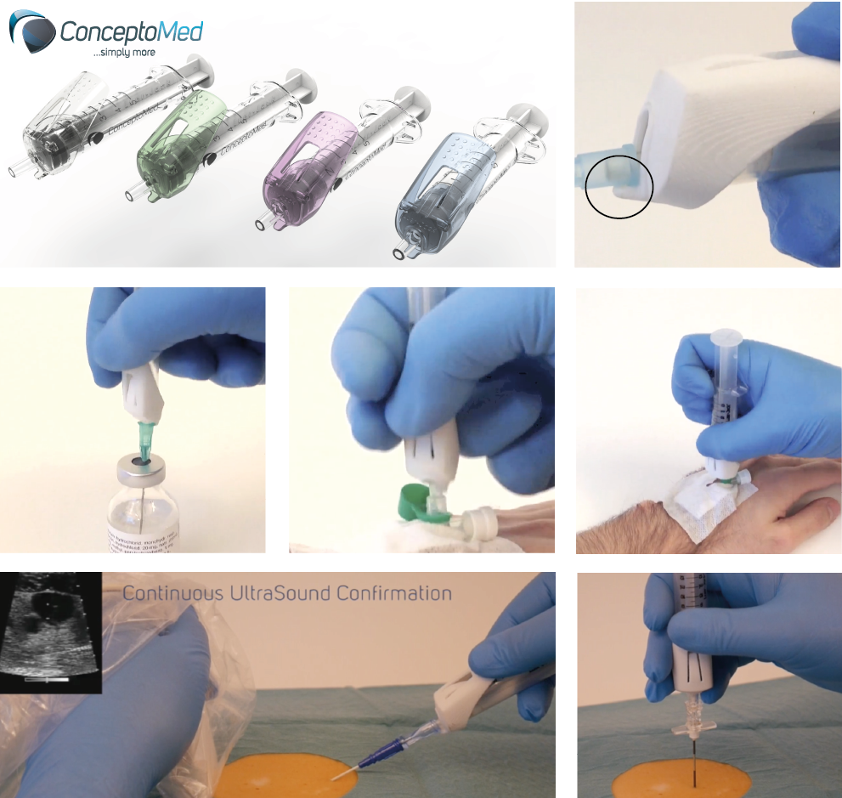
Luer-Jack™ is a unique medical syringe, which significantly increases control of the syringe and needles during disconnections. Standardizing disconnections, patient outcomes from procedures involving needle shift, will be less dependent on operator experience and proficiency.
OneHand
OneHand functionality for Luer-Jack™ will increase patient safety and comfort during disconnections - as well as being timesaving for the procedures.
Single-handed disposal with non-recapping of needles also represents enhancement to operator safety.
The “luer slip” standard for connections was established more than 100 years ago. Luer-Jack™ is based on the same “luer-slip” standard, but represents a fundamentally new approach to dealing with inadequate operator control during disconnection of syringes from female hubs.

- The UK national patent grant for Luer-Jack™ fits perfectly into the master plan for the IP processes being executed around Luer-Jack™. The patent grant is important for the further development, industrialization and market introduction of Luer-Jack™, says CEO Christian Mide.

