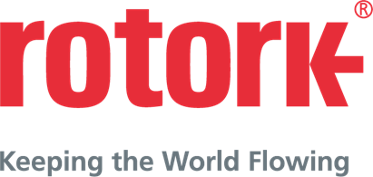
PRESS RELEASE (3.1049C) 20th November 2018
THOUSANDS OF ROTORK ELECTRIC ACTUATORS INSTALLED AT ZHOUSHAN OIL REFINERY
More than 2,500 Rotork IQ3 electric actuators have been installed at a Chinese oil refinery and petrochemical complex.
Zhejiang Petroleum & Chemical Company Ltd, which refines oil and manufactures chemical products, ordered the actuators for the refinery which is in construction on the island of Zhoushan, near Shanghai.
The actuators operate gate valves, ball valves and butterfly valves to control the flow of crude oil and refined product at the plant.
Zhejiang Petroleum & Chemical Company Ltd also purchased IB multi-turn bevel gearboxes which provide a torque range up to 8,135 Nm (6,000 lbf.ft) and a thrust range up to 1,320 kN (296,750 lbf.ft).
Zhejiang Petroleum & Chemical Company Ltd, which also offers oil storage and transportation services, says Rotork’s reputation for quality as well as the reliability of the IQ3 were key in its decision to buy from the business.
Rotork’s intelligent IQ3 electric multi-turn electric actuator allows the user unprecedented access to a wealth of data to maximise plant efficiency. Available in 1-phase, 3-phase and direct current variants, the IQ3 relays real-time information on an advanced dual stacked display which can be accessed even in the event of a power outage.
When complete the entire Zhoushan plant will feature two refineries capable of producing 400,000 barrels a day and two ethylene plants capable of producing up to 1.4 million tonnes a year.

END
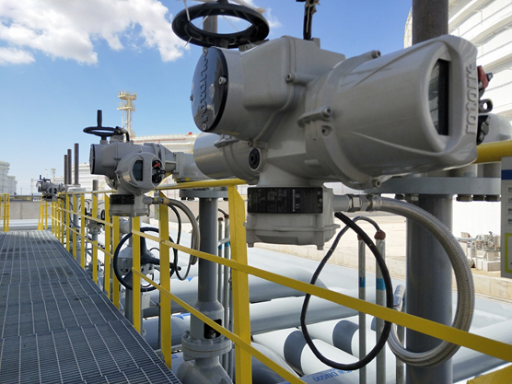
Photo captions
More than 2,500 Rotork actuators have been installed at the refinery.

For further information please contact Rotork PLC
Sarah Kellett Brassmill Lane
Group Marketing Communications Manager Bath
Telephone: +44 (0) 1225 733492 BA1 3JQ
Email: Sarah.Kellett@rotork.com UK

About Rotork
Rotork is the market leading actuator manufacturer and flow control company that operates in any market where the flow of gases or liquids needs to be controlled. It has established manufacturing facilities, a global network of local offices and agents who can truly provide a worldwide service. You will be able to locally source Rotork’s products, supported by life-of-plant maintenance, repair and upgrade services.

