Kongsberg Maritime to deliver large electric winch package to new vessel for Faroese fishing company JFK
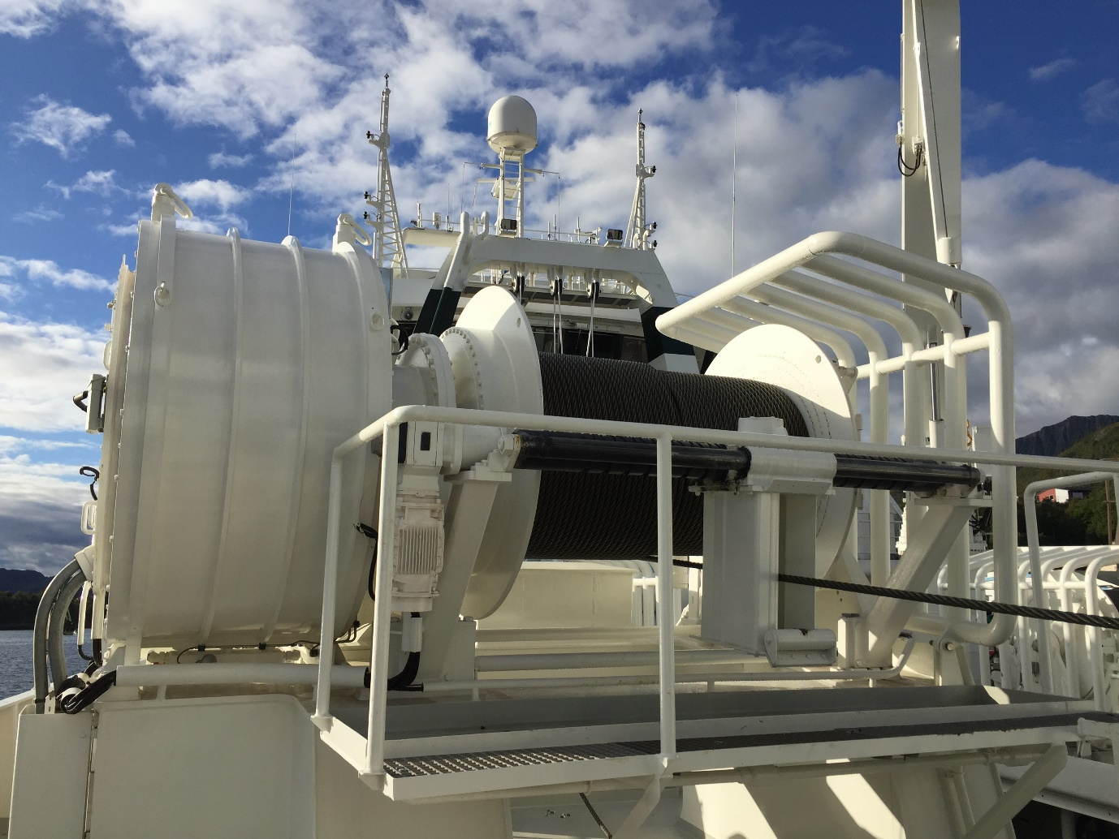
Kongsberg Maritime’s EasyDrive electric trawl winch, installed on board the stern trawler Granit
Kongsberg, Norway, 12th October 2020 – Kongsberg Maritime has signed a contract with Tersan Shipyard, Turkey, to equip an 86m stern trawler with a large winch package for Faroe Islands fishing fleet operator JFK. The package will include four EasyDRIVE electric trawl winches with SmartPΩWER Permanent Magnet (PM) motors. This innovative use of direct drive PM motors, instead of the gearbox arrangements customarily used for trawl winches, improves reliability considerably.
This will be the 13th stern trawler to be fitted with this system, which has so far logged 200,000 trouble-free hours and provides the ability to operate trawl winches via a motor connected directly to the drum. By eliminating the gearbox – an acknowledged weak link in a traditional setup – the risk of downtime or failure is significantly reduced. The system brings other, additional benefits, including high efficiency and regenerative power, and the ability to boost pulling force by up to 30% for short periods. It also gives very good dynamic properties and response times on the drum, an especially important consideration for stern/bottom trawling.
In addition to the unique trawl winches, Kongsberg Maritime will also deliver winch control and monitoring systems, and a Variable Speed Drive (VSD). These technologies work seamlessly to achieve the best possible functionality and operational reliability, resulting in a fantastic tool to facilitate efficient and gentle recovery of the catch.
Hanus Hansen, CEO and main owner, JFK: “We have been a customer of KONGSBERG/Brattvaag for many years and are very satisfied with the products and service they have provided. Until today, this has been with hydraulic low-pressure winches, but since they can now offer electric trawl winches with direct drive, we chose to adopt this form of drive on our new trawler.
“Prior to concluding the contract with Tersan Shipyard, we consulted with the fishery company K. Halstensen and their crew on board the trawler Granit. They were early to install these electric winches and have gained several years of experience. The feedback from them has been very positive. Kongsberg Maritime has served us well for decades, and we look forward to maintaining our mutually loyal relationship with the new electric PM winches.”
Ends

For further information, please contact:
Gunvor Hatling Midtbø, VP Communication
Kongsberg Maritime
Tel: +47 9921 4209
gunvor.hatling.midtbo@km.kongsberg.com
David Pugh
Saltwater Stone
Tel: +44 (0)1202 669244
d.pugh@saltwater-stone.com

About Kongsberg Maritime
Kongsberg Maritime is a global marine technology company providing innovative and reliable ‘Full Picture’ technology solutions for all marine industry sectors including merchant, offshore, cruise, subsea and naval. Headquartered in Kongsberg, Norway, Kongsberg Maritime has manufacturing, sales and service facilities in 34 countries.
Kongsberg Maritime solutions cover all aspects of marine automation, safety, manoeuvring, navigation, and dynamic positioning as well as energy management, deck handling and propulsion systems, and ship design services. Subsea solutions include single and multibeam echo sounders, sonars, AUV and USV, underwater navigation and communication systems.
Training courses at locations globally, LNG solutions, information management, position reference systems and technology for seismic and drilling operations are also part of the company’s diverse technology portfolio. Additionally, Kongsberg Maritime provides services within EIT (Electro, Instrument & Telecom) engineering and system integration, on an EPC (Engineering, Procurement & Construction) basis.
Kongsberg Maritime is part of Kongsberg Gruppen (KONGSBERG), an international, knowledge-based group that celebrated 200 years in business during 2014. KONGSBERG supplies high-technology systems and solutions to customers in the oil and gas industry, the merchant marine, and the defence and aerospace industries.
Web: Kongsberg Gruppen | Kongsberg Maritime
Social media: LinkedIn | Twitter | Facebook

