eFuzion: Innovative Technology for a Sustainable Future

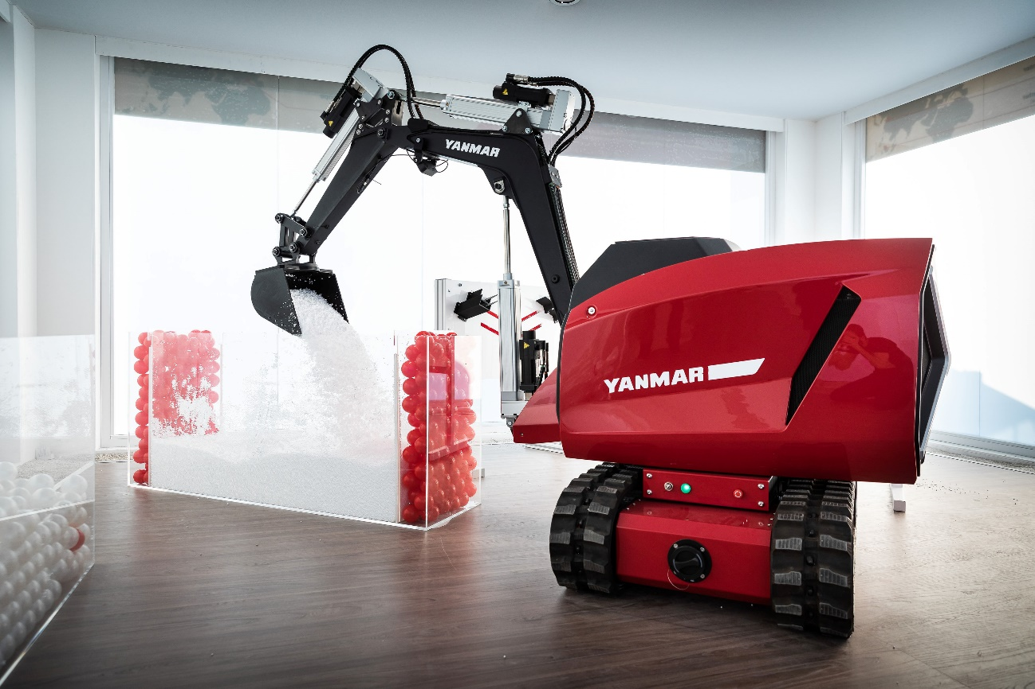
The Yanmar eFuzion Concept

Back in April, Yanmar unveiled its innovative and original, new concept construction equipment vehicle “eFuzion” at BAUMA 2019 to excited crowds of media, dealers, customers and construction equipment aficionados. Packed with innovative technology, the eFuzion concept demonstrates the depth and breadth of Yanmar’s global R&D, investing effort in developing and implementing innovative technologies to inspire creativity and unleash future possibilities.

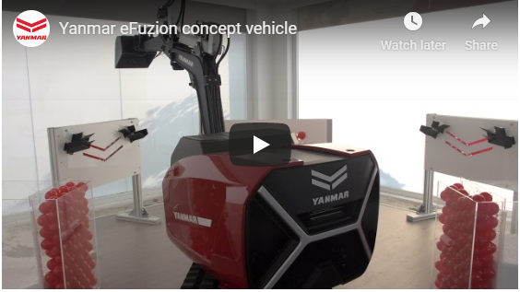
The eFuzion concept on display at the eCubator at Bauma 2019.

The eFuzion concept, primarily developed by Yanmar’s robotics research team, is a working demonstration of a precision machine with a robot arm that shows the possibilities of autonomous construction machinery of the future.

[INFOGRAPHIC]

Y Media caught up with Marta Niccolini, the lead researcher on the project and Jemylia Raimbault, Head of Marketing for Yanmar Compact Equipment – who has over 12 years in Global Marketing and Strategy positions in the Energy and Electricity industry - to find out about the a little more about the background to the eFuzion and learn some more about Yanmar’s robotics research.
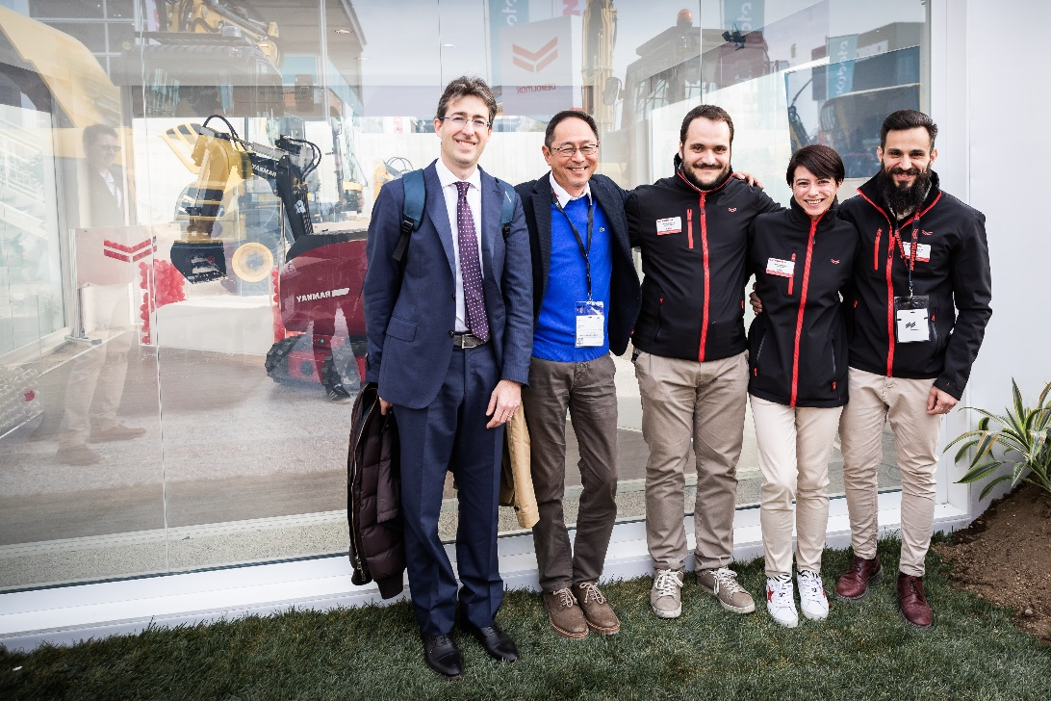
Marta Niccolini (second from right) with from left: Alessandro Belissima and Toyohiro Goto from Yanmar R&D Europe, and researchers Matteo Ragaglia and Alfredo Argiolas in front of the eFuzion concept at Bauma 2019.

YMEDIA: Thanks for your time today Marta. Can you tell us a little bit about yourself?
Marta Niccolini: I'm 37 years old, I'm Italian and I'm a control and robotics engineer. I have a lot of interest in robotics, also in my personal life. So I do a lot of robotics projects in my free time but I also like to make home-brewed beer, and in the winter I go snowboarding. I've worked in Yanmar for 6 years now.

YMEDIA: How did you become interested in robotics?
MN: When I was a child, I was always curious about how things worked, and I used to disassemble a lot of my mother's things, like the vacuum cleaner and so on. Then when I was a 15 or 16, I started developing some electronics by myself and programming microcontrollers and that's what got me interested in robotics and mechatronics - to get mechanical things to move but with some intelligence provided by the electronics, the sensors and so on.

YMEDIA: So, did your mother get angry at you when you took the vacuum cleaner apart?
MN: Yes, sometimes! Because I disassembled it and I tried to put it back together, but there were always some parts left over (laughs).

YMEDIA: How did you come to work at Yanmar?
MN: At high school, I started to study to become a teacher. Basically, I didn't like studying, but my parents forced me to at least do that much. But then when I got older, I discovered that I liked math and physics much more than psychology or philosophy. So, I decided to start computer engineering, and then I specialized in control and robotics engineering. I went on to do my PhD. at the University of Pisa for 3 years and then I switched to a doctoral position in medical robotics at a research center.

YMEDIA: Then this is your first company position after your doctorate?
MN: Yes, the first one. I decided to join Yanmar because it gave me with the chance to continue doing research but in a more applied way, on real products. That's why I decided to switch from an academic career to one based on working at a company.

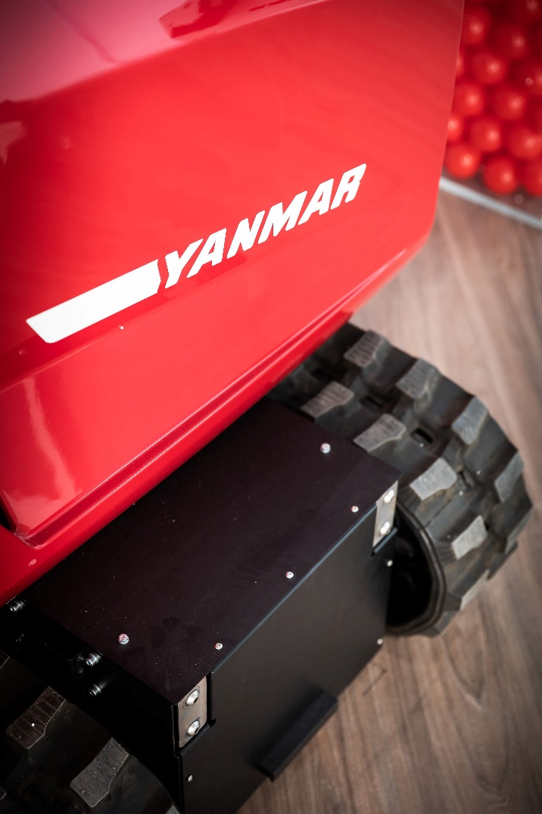
YMEDIA: What advice would you want to give to a student who might want to follow in your footsteps and have a similar career?
MN: Basically, one has to follow the passion they have because otherwise this could become quite hard work and quite stressful. But if you have a lot of passion, if you like what you do, it becomes like a hobby. Also, I think you should always believe in what you do. Even if at first you think that something is impossible, it may become possible, and you might be able to realize it if you believe in it.
YMEDIA: Okay, pretty good advice. Thank you.

YMEDIA: Does Italy have a dynamic robotics community?
MN: There are companies doing robotics but most activity takes place at the academic level, and one of the problems that Italy is facing is the lack of research from companies. That's why in my opinion, Yanmar was unique from this point of view.

YMEDIA: What are some of the challenges of "field robotics"?
MN: Yes sure. Well, many jobs in construction are made for humans, even when you consider the materials. For example, bricks are made for the human hand. But also, the processes that are behind construction are generally designed to be done by humans. So, if you want to introduce robots at all, you need to change a lot of parts; both the components and the processes involved.

YMEDIA: Many people don't have a clear idea about the line between mechanization and robotics. So, is there a line? How do you define those things differently?
MN: The main difference between the robotics and mechanization is that mechanization provides the tools to do a job that was previously done by hand. But in this case, the human is 100% responsible for all of the movements and activities that the machine is doing. A robot is a little different, because the robot, in my opinion, has a perception of what's happening around it, so it can understand what's happening and can make a decision and can act autonomously. Sometimes there is a need for a human operator to make it to move the right way or take decisions, but the main difference is that in a mechanized tool, 100% is of the control is human, while in robotics, the machine itself understands the situation and takes a decision or undertakes some autonomous action.

YMEDIA: It seems that robots are in the news quite a lot these days and when you think back about five years or 10 years, I mean I think there really wasn't very much in the way of robots in society, perhaps in car factory and some other areas, yes, but not in general society... What's changed? Why has this become much more of a common everyday occurrence do you think?
MN: Yeah basically, I think what is driving this progression is certainly improvement in the performance of sensors and batteries and also size. There is also the issue of computational power of the CPU. In the last year we have a very, very, small electronic component with a very high computational power which allows the robots to reason. Also, there are new algorithms and technologies that allow a robot to recognize its surrounding environment, for example by means of vision and artificial intelligence. There is also another factor in my opinion that is driving this very fast development of autonomy, and that is the very large community in robotics. There is a lot of sharing of tools and code between universities and also companies.

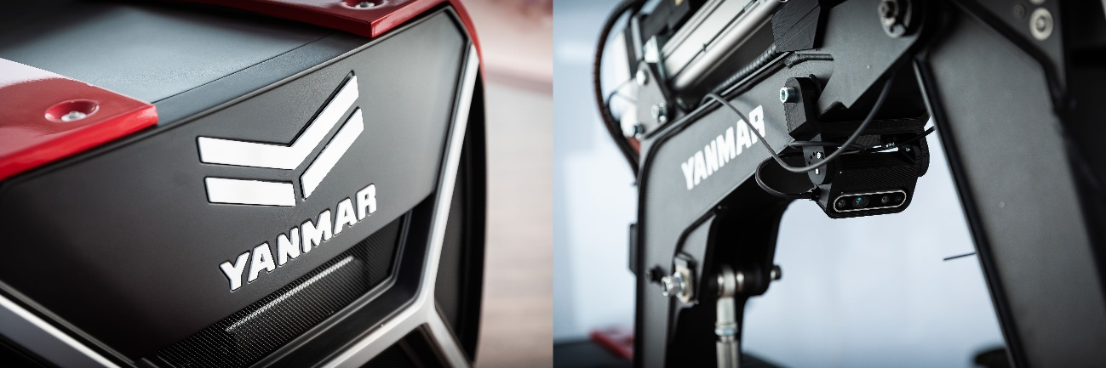

Jemylia Raimbault: So, the pace of development is increased because there is a sort of a Uberization of the capacities all over the community.
MN: Yes, and this is very important because it allows very fast development of new technologies without having to starting from zero.

YMEDIA: Interesting, so there is quite a large robotics community?
MN: Yes, it's a large community which makes available a great many tools and algorithms that are already developed and tested.
JR: For me, what I see is that we have more and more robots around us, but we're not really paying attention to them.
Whether it's your cooking robot or whether it is your Roomba that is cleaning your house or wiping the floor etc., it is there and it's more convenient. So what has happened is that as the technology has improved, as Marta said, with the battery price and performance improving and greater computational capacity and more, people realize that as the technology has improved it is now more affordable and people can now outsource to robots these low added value or repetitive tasks that a human would once have done. These tasks are put out to robots so that humans can enjoy better quality time in a society that is becoming more and more hectic.
I think this is reflected the spirit, if you will, of today's society. If you look at say, generations X, Y or Z, the Y and the Z generation are not interested in working long hours for the sake of it but are keen to have more fun and enjoy their life, beyond the working environment. So, they have no issue doing anything they can to minimize laborious tasks or externalize them to robots.

YMEDIA: So changes in society are driving this too
JR: I think it's a change in mentality. Generation Y ("digital natives" as we can call them) or the Generation Z (also called the C generation for Communication, Collaboration, Connection and Creativity) are more open to welcoming robots because they were born with these technologies: with the internet, with connections, with things being done by computers or robots. I think it shows how some segments of society are more open to a world with greater robotization.
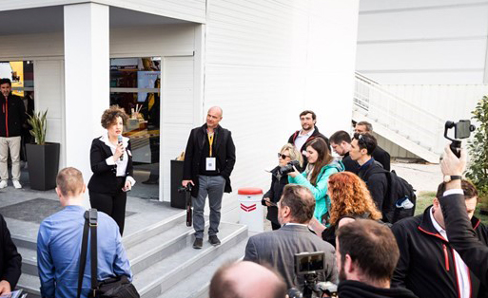
Jemylia Raimbault hosts the eFuzion unveiling at Bauma 19 in April

YMEDIA: We touched on this before, but field robotics is something that is not so well known. Can you tell us about some of the differences between field robotics and say, the autonomous vehicles we have on the road, and what are some of the special challenges you have in that area?
MN: Sure, yes. Basically, one of the main differences between field robotics and autonomous vehicles is that field robotics need to take some action on the environment.
Now, if you think of the example of an excavator that needs to dig a hole, you can see that this is not as easy as it seems. It needs to interact with the ground. And this activity seems to be quite easy but in reality, the expertise of the operator that is actually doing the work is a very important factor in the final result. So, one of the main differences is the interaction with the environment.
I think another challenge, especially for the mini excavator, is that the mini excavator is used for a lot of jobs. So sometimes the excavator will be carrying a load. Another time it will be demolishing something. If you want to introduce autonomous technology in that situation, you need to make it flexible enough to perform the same jobs they're doing today. They are used for a lot of different tasks so it's quite difficult to make a completely autonomous machine to handle all those tasks.
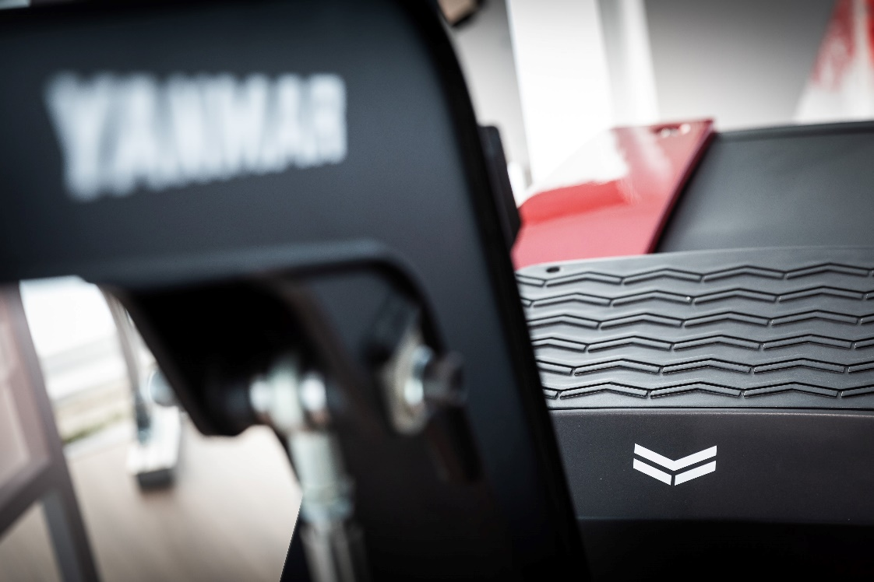

YMEDIA: Is there more autonomy and robotics coming into construction equipment now, and if so, why is that?
JR: I think, and Marta again correct me if I'm wrong, from what we have seen at BAUMA, there is more and more electrification of machinery, but not necessarily much in the way of robots or autonomous machines. There are some attempts at remote control for safety reasons and convenience, but not so much actual robotization. You can have assistance, you can have connected machines, but not yet robotization. And this is where with Bauma and the eFuzion we really made a great leap.
The understanding today in construction is that with or without legislation, with or without the rules of the European law changing, there's a strong grassroots movement towards zero emissions and because of that companies have no other choice but to follow the pace.
But in terms of robots I don't see any robotization yet. Certainly, electrification... yes. And again, this is really where the eFuzion machine stood out. Not only does it implement electrification, but also the robotization with full autonomy.

YMEDIA: What do you mean when you say "assist technology" or "assistance" in the context of robotics?
MN: By assistance, I mean for example a grading assistant. The machine can help the operator to perform some maneuvers.
If you consider the job of grading, you need to move many joints at the same time. We now have a situation where we have a lack of expert operators that can do that job easily. They need a lot of training to perform that job and synchronize the movements of all the joints of the machine. As we saw at Bauma, some companies are working on a tool that allows the operator to just use a joystick to move these multiple joints of the machine. The machine performs the grading movement and the operator can do this by just moving one lever.
JR: You also have now a number of companies both in Europe and Japan that are all working around the construction machine to give it this kind of assistance capability. This can help you, for example, to visualize underground pipes in 3D, whereas before, you could only do your best with maps or plans. They will assist you in knowing, for example, if the machine has been working without being switched off. Rental companies will be able to know in detail and in real-time about the operating conditions of their equipment. This is all a kind of assistance from geo-localization to feedback on how the machine is performing or allowing you to do a better job with better knowledge about the environment.
This is what we called making the machine smarter or what I call it: making the machine more intelligent. This is I guess what Marta is telling you by providing more assistance.
MN: Another good point about introducing robots in construction is that now building plans and even construction site plans are made digitally. So before, all drawings were made on paper and for a robot it was quite difficult to reason based on a paper drawing. Now everything is 3D, is on the cloud, so all the stakeholders in the construction field can work according to the same digital drawing. The machine can also be connected to this digital drawing, and this helps the machine work with a perception of the environment, as in the example that Jemylia was describing about the pipes.
JR: This is the BIM data we also used with eFuzion.
MN: Another thing regarding assistance is augmented reality. You have digital drawings and there are some tools, for example the Hololens from Microsoft, that you can provide to the operator, and then your operator can see the real environment while simultaneously seeing a digital version of the same environment.

YMEDIA: I know that the eFuzion is a concept and a technology demonstrator, but what do you see is the future of construction robotics if you look at the long term?
MN: Yes, I believe that in years to come, robots will become a part of building and construction. However, at this time, if we consider the building and construction site, maybe the only robot operating - if we can call it a robot, because sometimes it is teleoperated, is a small robot that makes holes in the ceiling. So, at this time, we don't see very many robots in this field. I think things will change, first of all thanks to this BIM technology but also thanks to new advances in robotics.
MN: In our research, we visited a lot of construction sites, especially sites for tall buildings. What makes these worksites suitable for robotization is that these tall buildings are expensive and there is a lot of work that can be considered repetitive, compared to the construction of small buildings. The machine that we have developed here also has precision characteristics, so one field that we would like to investigate is how to use this machine and in an indoor environment. Since it's fully electric, it can work indoors, and it has precision capabilities that allow it to be used for many kinds of precision work in construction. Furthermore, it's connected to BIM, so we can instruct the machine to carry out repetitive tasks and keep a precise positioning of where the components should go, directly from the planning drawings.
JR: One thing many companies are looking at, is how various types of equipment can be integrated into the smart grid of the urban environment of the future. This includes power companies, transportation, as well as a lot of players who have not traditionally been involved in urban planning and construction. One example is where you have large IT companies are starting to become active in this area as they are heavy consumers of power from the grid, and therefore have a large interest in energy resources, even though they are not traditional players in the industry. The eFuzion is an example of equipment that could possibly in the future, plug into and be part of this smart urban grid, and I have heard some interest in informal discussions with energy companies.
Certainly, there will be disruption of these industries.

YMEDIA: Very interesting. Thank you both for your time.

