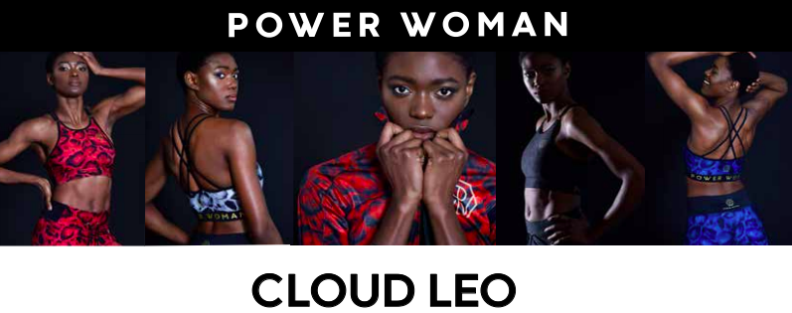
2019-08-23 – Stockholm, Sweden
We are Proud to Introduce or Latest Collection – Cloud Leo

Because we love animal patterns and leopard patterns in particular, we were looking for a unique and new variant. We found it in the very unusual tree leopard "clouded leopard". The tree leopard lives in inaccessible areas, mainly in rainforests, in eastern Asia. It is very shy and the species is strongly endangered. Because we want to pay tribute to individuality and show strength in uniqueness, we made a pattern based on the very rare pattern these leopards have.

Beluga Black, Sapphire Blue, Platinum & Oriental Red

The base color is greyish brown, but with large black leopard spots with contours like rings in irregular patterns. We chose to put the pattern in bold autumnal tones such as deep red, black on black, dark blue and a white gray in an elegant and sophisticated ensemble.

We hope you, like a cloud leo, take pride in being the unique creature you are.

Press Contact: Anna Wretling
E-mail: press@powerwoman.com

Power Woman
Power Woman is a Swedish high-end sportswear brand. Power Woman design sports apparel that are perfect for the female body and extensively tested by the world's top female athletes. The apparel combine fashion, fit and sports in one. Behind the brand stand entrepreneur and triathlete Anna Wretling who´s passion is to empower women through the brand and through the sports community Team Power Woman Athletic Club.

Team Power Woman Athletic Club – Non profit
Team Power Woman Athletic Club is a team of individuals whose drive, and main goal is to support each other. Founder, serial entrepeneur and triathlete Anna Wretling wanted to create a loving community where everyone always feels welcome. It’s not important if you are a professional or a beginner. ”- The only ”requirement” I have, is that we are kind to each other” says Anna.
A membership at Team Power Woman is free of charge, because we want everyone to have the opportunity to be a part of our team. Team Power Woman Athletic Club has +1100 members and are members of the Swedish National Sports Association, The Swedish Triathlon Association, The Swedish Cycling Federation and The Swedish Ski Federation. This allows you to compete with a license in our Team Power Woman Athletic Club.

