2022-05-11

PRESS RELEASE

Doctoral thesis reveals the technology behind a space instrument built to study Jupiter
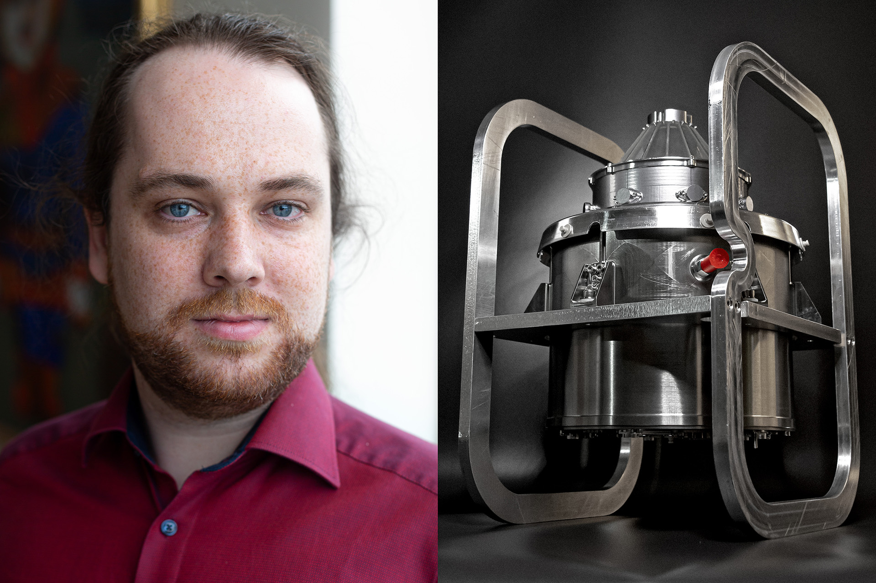
Philipp Wittmann has during his doctoral studies at the Swedish Institute of Space Physics built a space instrument to measure ions and electrons in the Jovian system onboard the Jupiter ICy moons Explorer (JUICE). Photo: IRF

On May 13th Philipp Wittmann, Swedish Institute of Space Physics (IRF) and Umeå University, will defend his doctoral thesis. Philipp has been part of developing, testing, and calibrating the particle instrument Jovian plasma Dynamics and Composition analyzer (JDC). It will measure ions and electrons in the Jovian system onboard the upcoming European spacecraft JUpiter ICy moons Explorer (JUICE).

The JUICE spacecraft will be launched in 2023 towards Jupiter and the main scientific goal of the mission is to study the habitability of Europa, Ganymede, and Callisto, three of the four Galilean moons. The particle instrument JDC will contribute to this study by measuring ion and electron fluxes, their dynamics and the different types of ions present in the Jovian system.

“The uniqueness of JDC is a combination of a very compact sensor design and the capability to measure not only positive but also negative ions with the same instrument. I worked on four different versions of the instrument including the unit selected to fly to Jupiter,” says Philipp.

Philipp’s work included the implementation of design changes for improved instrument ventilation, the design and implementation of electronic boards, integration of the different versions of JDC, surface treatments and a variety of environmental tests. He also calibrated both the flight unit and the flight spare unit.

To make sure that JDC’s detectors can handle the number of particles accumulated during the whole mission at Jupiter, Philipp implemented a lifetime test for the detectors.

“In a lifetime test the detectors are illuminated by a particle source and the registered signals are accumulated. When the accumulated number of particles registered exceeds the estimated number of particles the lifetime test is considered successful. In the lifetime test not only this estimate was exceeded, but also the expected operational time of JDC”, says Philipp.

JDC is, together with five other instruments, a part of the Particle Environment Package (PEP), one of the two Swedish payloads of the JUpiter ICy moons Explorer.

Philipp Wittmann, born in Germany, defends his PhD thesis titled “The Jovian Plasma Dynamics and Composition Analyzer (JDC) for ESA’s JUICE mission” on Friday the 13th of May 2022 in the auditorium at IRF in Kiruna. The faculty opponent is Dr Frédéric Allegrini from the Southwest Research Institute in the USA.

The doctoral thesis: https://umu.divaportal.org/smash/record.jsf?pid=diva2%3A1651880&dswid=-1379
Contact:
Philipp Wittmann, PhD, Swedish Institute of Space Physics (IRF) and Umeå University
philipp.wittmann@irf.se
+46 980 79073

