PRESS INFORMATION

Reliable connection of steel to concrete
The new HALFEN Insulated connection, type HIT-SMV for reliable connections

Langenfeld – (February 2020)
The high thermal conductivity of the material between steel components and reinforced concrete slabs can easily become a critical weak spot in a façade.
The new HALFEN HIT Insulated connections ensure reliable installation of steel balconies, canopies, shading systems and other façade elements. They provide effective thermal separation in connections, and consequently prevent damage to
the building.

Three variants for different applications
The HIT-SMV Insulated connector has an insulation core and appropriate steel reinforcement bars for reliable transfer of loads. This system for connecting filigree, steel components to concrete reduces thermal bridges to a minimum with simultaneous high load transfer. HALFEN has three connection types available:
Both the SDV and SMV versions are suitable for connection of cantilevered steel components with negative bending moments. In addition, the SDV is also suitable for positive bending moments. The SZV, though, is used as a connection for simply supported steel components to reinforced concrete slabs. All three types are suitable for positive shear loads.

These benefits have also been verified by building authorities
Installation is quick with an integrated adjustment bracket. This allows the HIT Insulated connection to be freely height adjusted to compensate for on-site tolerances. A General Building Authority Approval no. Z-15.7-336 is available.
In accordance with DIN 4108-2 and EnEv, the connections reduce thermal bridges, minimise energy loss and prevent condensation and mould. The non-flammable insulation core is available in 80 and 120mm thicknesses and are building material class A1 consisting of thermal insulating, fire protection material.
ca. 1.750 Zeichen inkl. LZ
Picture:
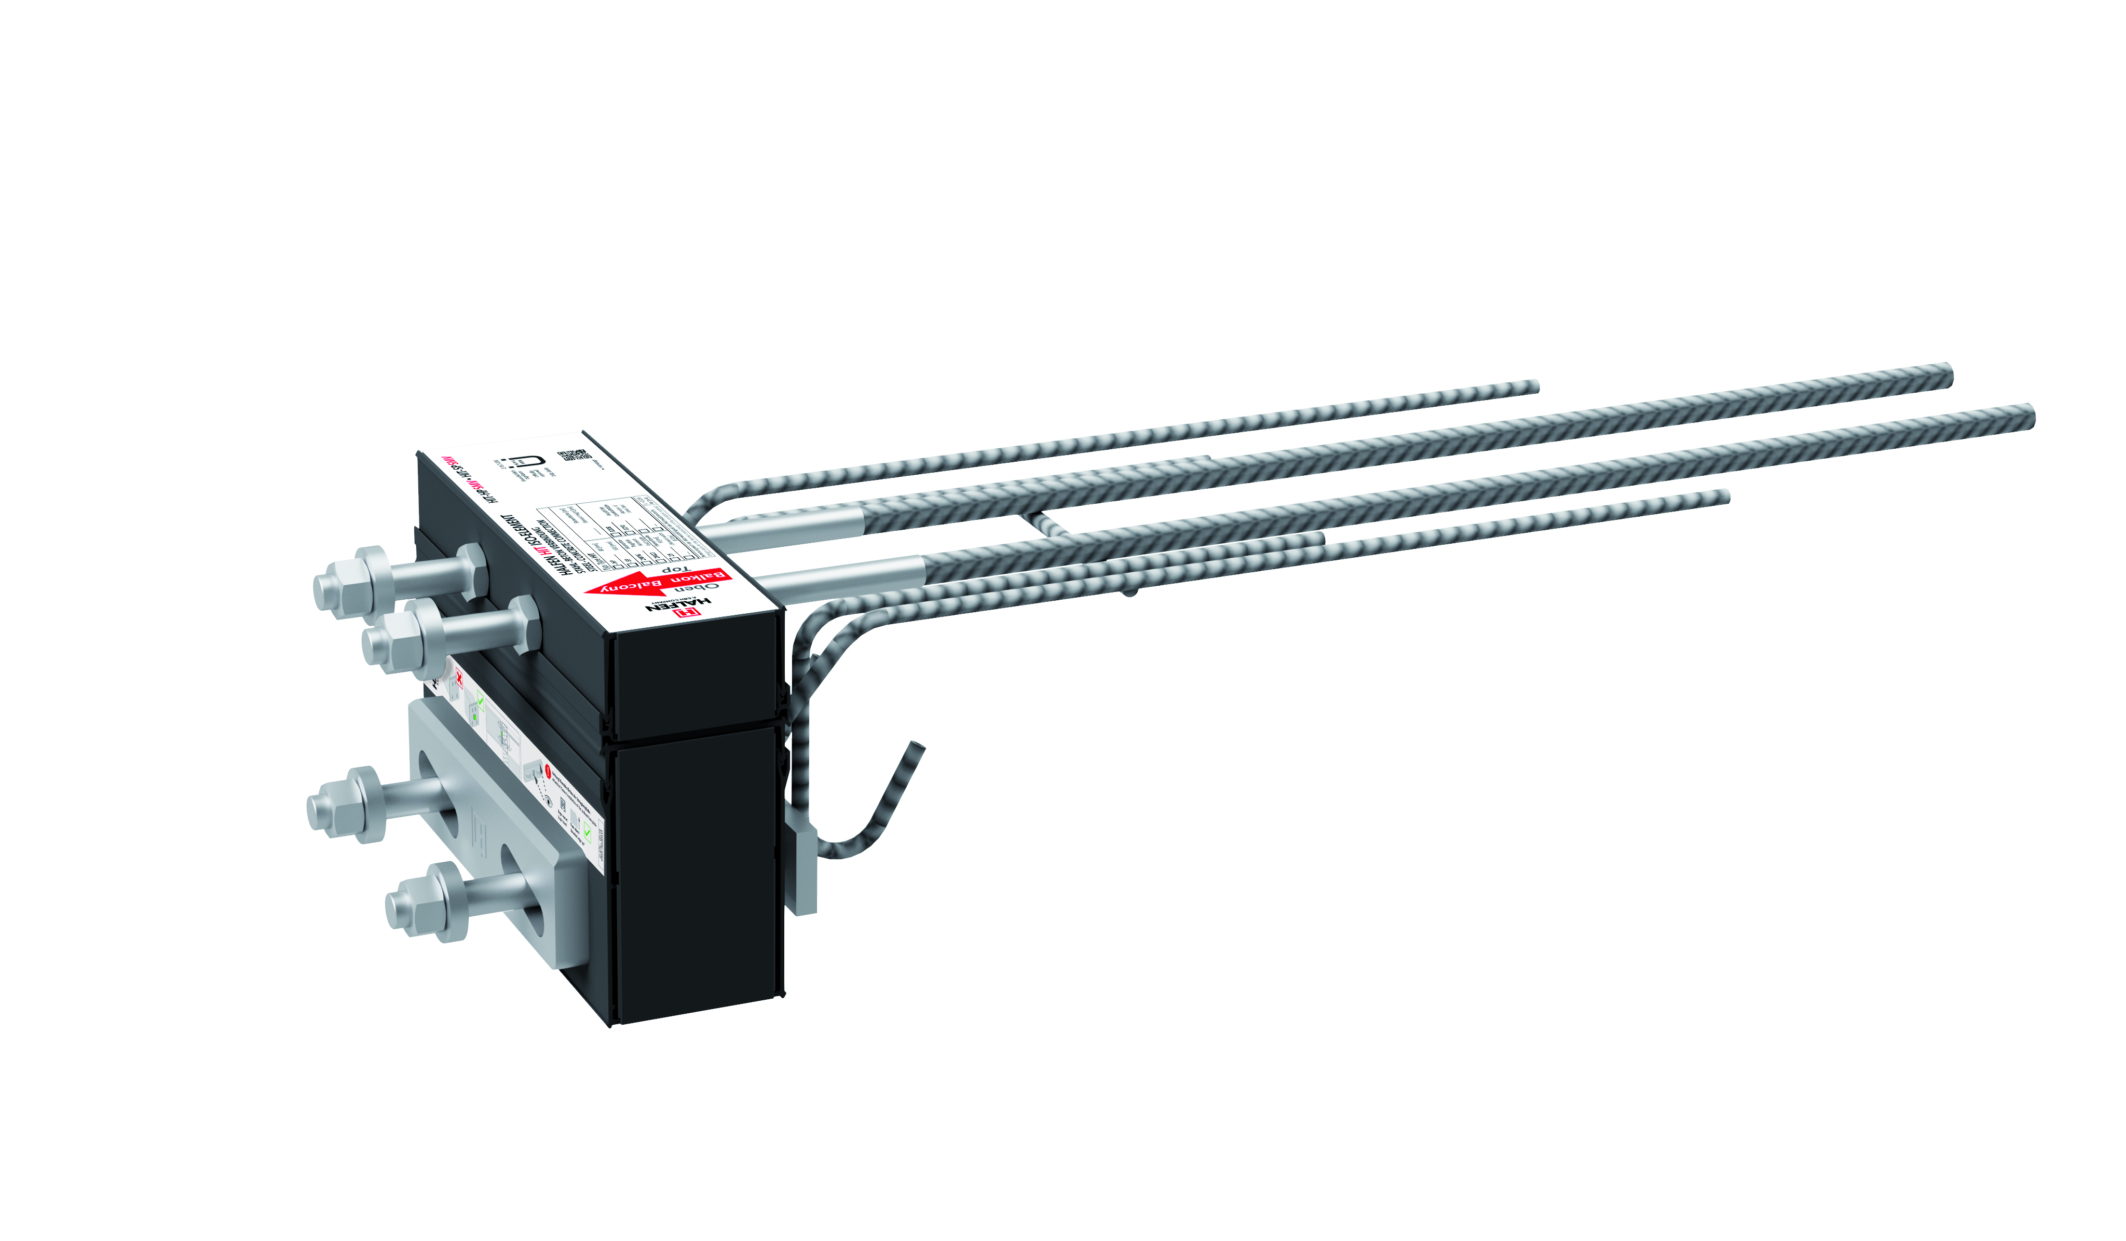
The new HALFEN HIT-SMV Insulation connector, ensures a reliable connection of steel components to concrete. Picture: HALFEN GmbH

The text for the press release and high-resolution photographs are available on our press portal. Download from (presseportal.brandrevier.com/halfen/).

About HALFEN:
With over 1,000 employees in 14 countries and more than 20,000 products HALFEN GmbH is internationally one of the most successful companies in concrete anchoring, façade connections and framing technologies. We provide our customers with high-quality products for precast concrete construction, for commercial and residential projects as well as for civil engineering including transport and infrastructure projects. Information for editors:

Contact: | Editorial:
HALFEN GmbH | Brandrevier GmbH
Simone Winandi | Saskja Jagenteufel
Marketing and Communication | Tel.: +49 (0) 201 /874 293 23
Tel.: +49 (0) 2173 / 970-195 | jagenteufel@brandrevier.com
simone.winandi@halfen.de

