Annex A: Winners’ biographies and supporting qutoes
Ishan Shukla, Director
Schirkoa (India)
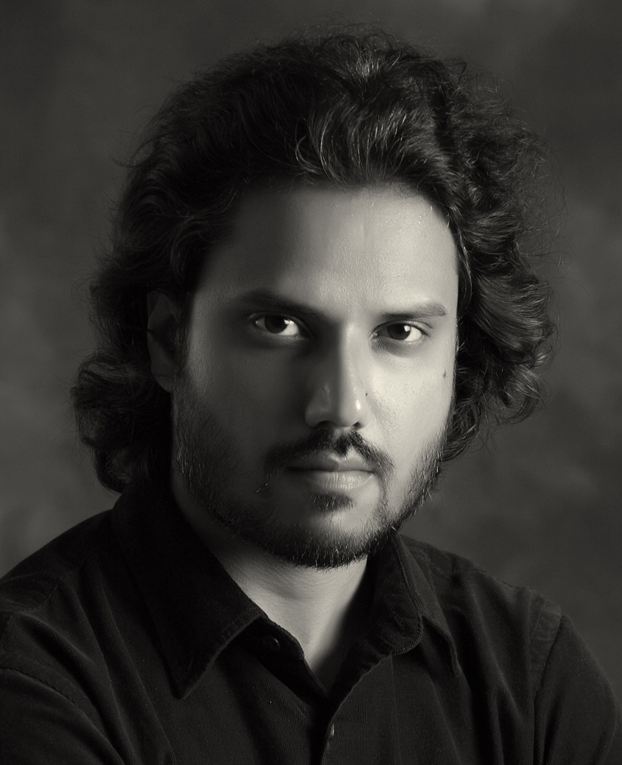
Ishan is an award winning Indian CG Artist and Filmmaker working in the animation medium for the past eight years. Ishan has a strong penchant for storytelling and has been engaged in creating comics, films and stage-plays since childhood. After dropping out of an engineering college to pursue animation, he graduated from 3D Sense Media School Singapore in 2008. Between 2008-2012, he was based in Singapore spearheading projects ranging from TV commercials to TV series. Ishan then took a two-year sabbatical to work on his short film, Schirkoa. The look and design of the film is inspired by both classic anime and modern stylized games. He is now working as a CG Lead at an animation studio in India while working on personal projects in spare time. His animation shorts and artworks have won several awards and have been featured on various online portals.

“It is a tremendous honor to receive this award. I attended the very first SIGGRAPH Asia back in 2008, and I was sitting in the electronic theatre in awe. Looking at those beautiful artworks from all over the world wondering ‘wouldn’t it be something to have my own film screened on this prestigious screen’? Thanks to the ACM Siggraph for this huge award and for pushing me to become a better artist! I have never been so inspired and excited for my next project.”

James Cunningham, Director
Accidents, Blunders and Calamities (New Zealand)
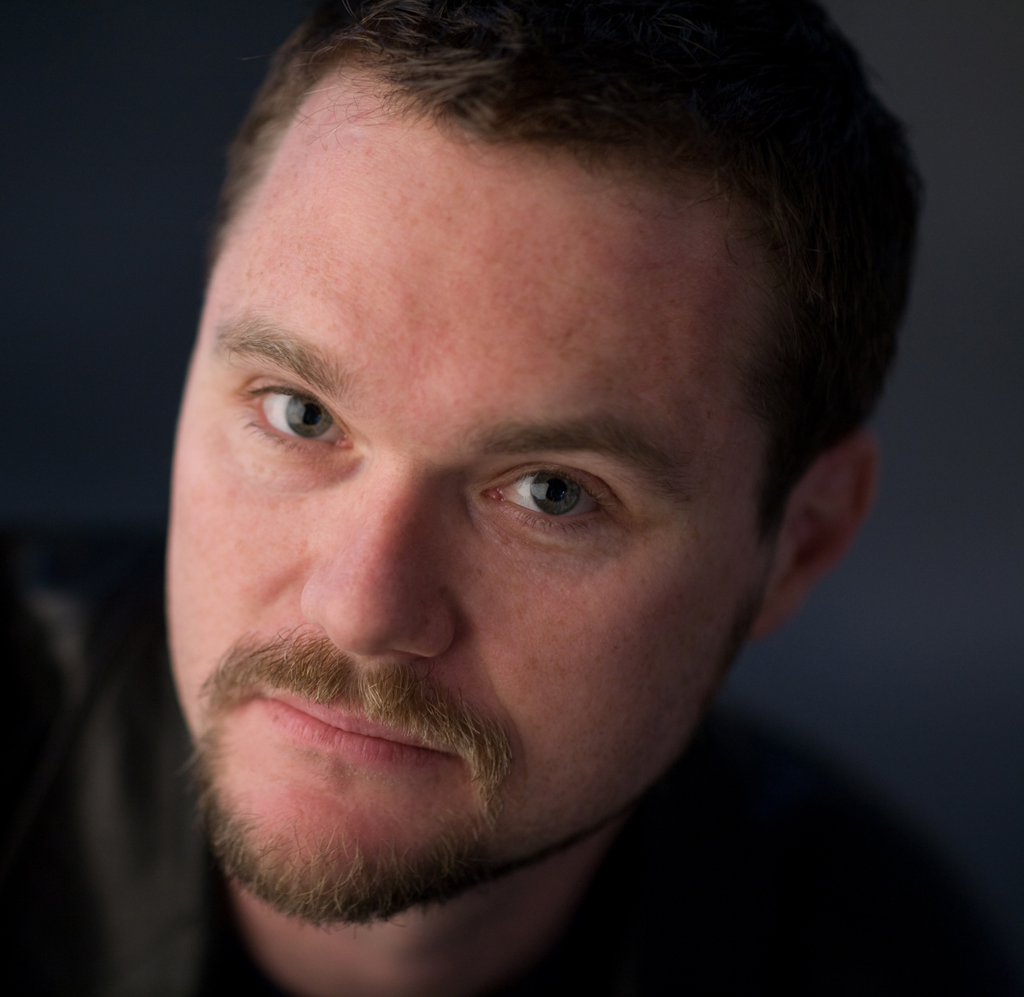
James started out as an animator/director while completing his Masters’ degree at Elam School of Fine Arts. His 3rd film, INFECTION, competed at Cannes 2000, Sundance 2001 and dozens of other international Film Festivals and started off two key paths in his career. The first path being Director, and the second path is that of a Visual Effects Artist and Supervisor. In 2009, he took time out to make his second NZFC funded short film, POPPY, a 10min CGI motion-captured WWI drama about a man finding salvation in the midst of hell. This film took out the top prize at SiIGGRAPH Asia 2010. Since then, he has been teaching at New Zealand's top institution for animation and visual effects, Media Design School. Here he met colleague Oliver Hilbert and together they have made 10 films in eight years.

“It means so much for us to receive this recognition as it helps us measure the level of the work we produce. It gives our students great confidence in their abilities and helps them get noticed above the pack of other young people trying to get into the industry. It helps ease the memory of all the long days and weeks, making it worthwhile. It helps to inspire us to make more weird and quirky stories. To know lots of people have watched the film and have been amused/revolted is so important. But to know some very smart people on a jury REALLY liked it is awesome.”

Martin Lapp, Director
BreakingPoint (Germany)

Born 1988 in Tübingen, Martin studied at the Merz Akademie Stuttgart and later switched to the Filmakademie Ludwigsburg to study animation with a focus on Visual Effects. During his studies, he worked as a Visual Effects Artist as well as a VFX on set supervisor for professional films and advertisement projects. He was a CG Artist on several commercials and feature films at Method Studios in Los Angeles. He won the Visual Effects Society Award for his film “Rugbybugs”and was chosen “Student of the Year, Runner Up” at the annual Autodesk Student Awards. In 2015, he received a scholarship from Sony (Imageworks Professional Academic Excellence) and graduated with his diploma project “Breakingpoint” in 2016. He was selected “Student of the Year“ again “The Rookies“ (formerly Autodesk Student Awards) and currently works at Trixter Film in Munich as a FX Artist on Guardians of the Galaxy 2.

“The idea for BreakingPoint arose from personal events in my family, which relates to my sister giving birth, one year ahead of preproduction. We wanted to create something visually stunning - yet personal, this led to the idea for the short. Winning the Best Student Project Award at SIGGRAPH Asia is a huge honor for the whole team and we are more than thrilled about it. Thank you!”

